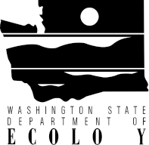

Department of Ecology - Water Quality Program
Freshwater Algae Control Program
Final Offer and Applicant List – Fiscal Year 2019

Application  Number | Applicant Name/Project Title | Rank | AWMF Funds  Offered | Footnote
WQALG-2019-WhIsCD-00009 | Whidbey Island Conservation District  Lone Lake Algae Management Plan | 1 | $50,000
WQALG-2019-SnCoPW-00014 | Snohomish County Public Works  Lake Loma and Sunday Lake Algae Control Plans | 2 | $45,000
WQALG-2019-LibWSD-00018 | Liberty Lake Sewer and Water District  Trophic Cascades Effects on Algae Blooms in WA Lakes | 3 | $40,000

