Chapter 9 Reasonable Progress Goals

Introduction (Note – figures and data may change slightly with updated modeling)
The regional haze rule (RHR) requires states to establish reasonable progress goals (RPGs) for the eight mandatory Class I Areas (Class I Areas) within the state. The RPGs, expressed in deciviews (dv), reflect visibility improvements during the current implementation period (2018 to 2028) for the most impaired days (MID) and ensure no degradation in visibility on the clearest days.
In the establishment of RPGs, the RHR requires states to consider both (1) the uniform rate of progress (URP shown as a glidepath) needed to attain natural conditions by 2064 and (2) the four factors required by the federal Clean Air Act (CAA) to determine reasonable progress.
Ecology’s evaluation of RPGs relies on technical data and analysis developed by the Western Regional Air Partnership (WRAP). Data are available on WRAP’s Technical Support System (TSS2) website (http://views.cira.colostate.edu/tssv2/). The source apportionment analyses discussed in Chapter 8 and the Class I Area summary table for each Class I Area were used in this analysis. Class I Area summary tables for Washington’s mandatory Class I Areas are in Appendix XX.
The RPG for each Class I Area is established by determining the baseline and projected visibility, examining the progress that has been made in reducing visibility impairing pollutants, and considering the four statutory factors.

Four-factor analysis (FFA)
The RHR specifies that a state must consider the four factors specified by the CAA in determining the RPG for a Class I Area (40 CFR 51.308(d)(1)(i)(A)). These four statutory factors are: the cost of compliance, time necessary for compliance, energy and non-air quality environmental impacts of compliance, and the remaining useful life of any potentially affected sources.
The screening of point sources is discussed in Chapter 11 and area sources are discussed in Chapter 10. Ecology requested a FFA focused on SO₂ and NO_{x} from facilities subject to the FFA. Ecology reviewed the FFA information submitted by the sources. The conclusions are summarized here and described in Chapter 11.
The Interagency Monitoring of Protected Visual Environments (IMPROVE) monitoring data show that ammonium sulfate (SO₄) and ammonium nitrate (NO₃) are two of the most significant pollutants impairing visibility in Washington’s Class I Areas. The projections made by WRAP for emissions show that they remain significant until 2028 and are largely anthropogenic in origin. A large fraction of the total SO₄ emissions are attributable to point sources with a relatively minor contribution from area and mobile sources as shown in the Q/d (emissions divided by distance to nearest Class I Area) analysis in Chapter 11. Most of the NO₃ emissions are attributable to mobile and point sources with a relatively small contribution from area sources. Ecology is focusing on SO₂ and NO_{x} reductions from point sources. NO_{x} emissions from mobile sources decreased significantly prior to 2018 due to the vehicle and engine provisions of Title II of the Clean Air Act and regulations at 40 C. F. R. Parts 85, 86, 88 through 94, 600, and 1033 through 1068.
Ecology evaluated projected 2028 SO₂ and NO_{x} emissions from specific industries and emission source categories as defined by Standard Classification Codes (SCCs). SO₂ and NO_{x} are precursors of SO₄ and NO₃, respectively. We first identified the major category SSCs projected to have the highest emissions of SO₂ and NO_{x}. The resulting three major source categories are industrial processes, external combustion boilers, and internal combustion engines. Emissions of both SO₂ and NO_{x} from individual specific industries and emission source categories within these three major categories vary greatly.
Ecology considered total regional haze causing emissions from the 2014 emission inventory of all major sources. The 2014 emission inventory was selected as it was the most recent certified emission inventory when regional haze work started. We focused on the major sources because they represent 10 percent of all sources, but contribute 88 percent of impact (total Q/d). Ecology looked at 18 specific industries to evaluate opportunities for emission reductions to improve visibility. Ecology focused its FFAs on the resulting set of 18 specific industries and their emission source categories. See Chapter 11 for details of the source selection process. The final list of sources selected for FFAs is provided in Table 2 of Chapter 11.
Ecology conducted FFAs for sources that affect Washington’s eight Class I Areas. The majority of selected sources are located along the Interstate 5 (I-5) corridor in western Washington and are capable of contributing to visibility impairment at more than one Class I Area. I-5 runs north-south between the Canadian and Oregon borders west of the Cascade Mountains in what is sometimes referred to as the Puget Sound trough. Seven of Washington’s eight Class I Areas border the Puget Sound trough to the east. The eighth Class I Area is located to the west of the Puget Sound trough on the Olympic Peninsula.
We conclude, based on the analyses, that there is the potential for SO₂ and NO_{x} emission reductions from a number of individual sources, principally boilers, process heaters, and fluidized catalytic cracking unit (FCCU)/carbon monoxide (CO) boiler systems. This conclusion sets the stage for future development of SO₂ and NO_{x} limitations for individual sources. New requirements for existing emission sources are set according to Washington State law through the Reasonably Available Control Technology (RACT) requirement in RCW 70A.15.2230.
"Reasonably available control technology" (RACT) is the lowest emission limit that a particular source or source category is capable of meeting by the application of control technology that is reasonably available considering technological and economic feasibility. RACT is determined on a case-by-case basis for an individual source or source category taking into account the impact of the source upon air quality, the availability of additional controls, the emission reduction to be achieved by additional controls, the impact of additional controls on air quality, and the capital and operating costs of the additional controls. RACT requirements for a source or source category shall be adopted only after notice and opportunity for comment are afforded (RCW 70A.15.1030).
This state law usually allows the sources a specific amount of time to upgrade the controls to meet the new or revised emission standards. It includes an economic hardship provision. A company that demonstrates it meets the criteria for economic hardship is allowed either an extended time to achieve compliance or an alternate, source-specific emission limitation.
Having identified feasible reductions through the four factor analysis, and to achieve reasonable progress goals, Ecology is proceeding with establishing and requiring controls on point sources of SO₂ and NOx. Development of controls is discussed further as part of Washington’s long-term strategy (LTS) in Chapter 10 and in the Chapter 11 four-factor analysis.

Progress in reducing visibility impairing pollutants
As discussed in Chapter 6, 2028 modeling reflects “controls on the books” throughout the West. Controls on the books are existing, legally adopted controls that will reduce visibility impairing pollutants during the second implementation period 2018 to 2028. Prominent examples are large statewide reductions in SO₂ (95%) and NO_{x} (64%) from on-road and off-road mobile sources between the 2000-2004 baseline and the 2018 projection as a result of engine and fuel rules. These and other controls are discussed in the Chapter 10 long-term strategy (LTS).

Olympic National Park

Most impaired days

Baseline and projected visibility
The monitored 2000-2004 baseline visibility at this site on the most impaired days (MID) is 14.9 dv and calculated natural conditions are 6.9 dv, a difference of 8 dv. This second RH SIP covers the second implementation period 2018 to 2028. The 2028 reasonal progress goal (RPG) is projected to be 11.4 dv, which is a visibility improvement of 3.5 dv from the baseline. The uniform rate of progress or glidepath value is 11.7 dv in 2028.
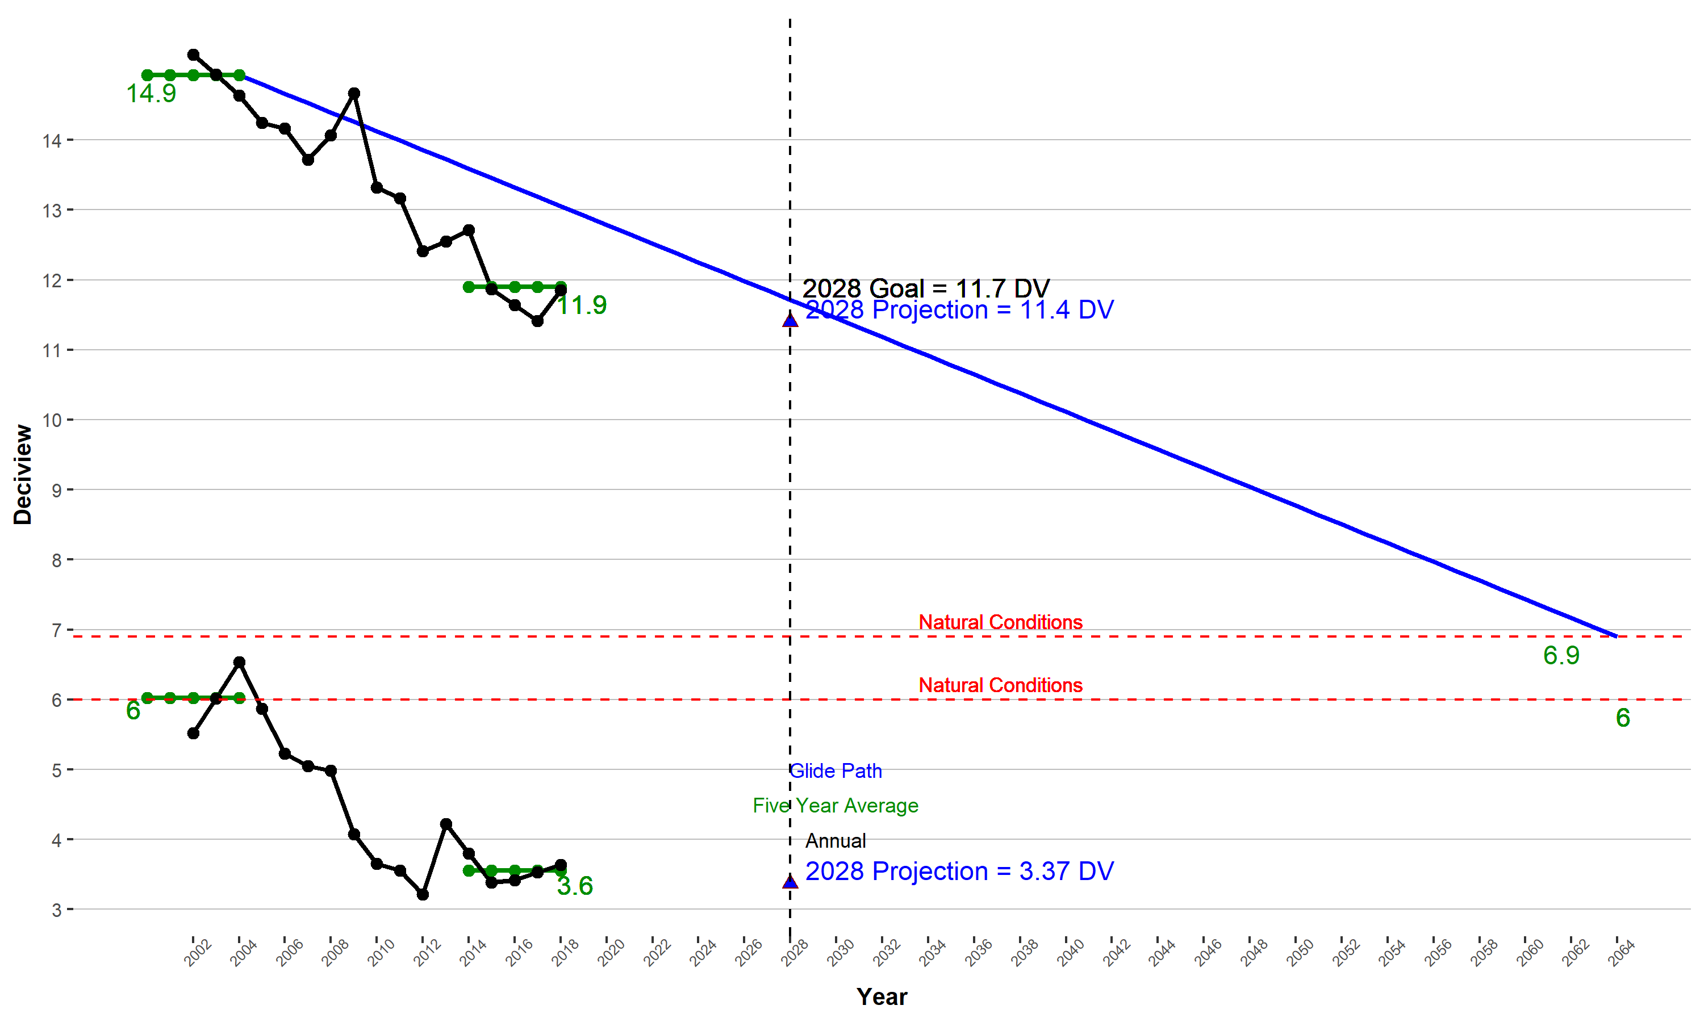
Figure 1: Projected 2028 visibility conditions on the MID in Olympic National Park

Progress in reducing visibility impairing pollutants
More information coming after modeling rerun
Sulfate: More information coming after modeling rerun
Organic Matter Carbon: More information coming after modeling rerun
Nitrate More information coming after modeling rerun
Summary: Ecology concludes from this analysis that progress is being made in reducing visibility impairing pollutants impacting Olympic National Park.

2028 reasonable progress goal for the MID
Ecology concludes that 11.4 dv is the 2028 RPG for Olympic National Park assuming emission controls on the books.

Clearest days
The monitored 2000-2004 baseline conditions at OLYM on the Clearest Days are 6 dv. This second SIP covers the 2018 - 2028 period. WRAP modeling projects 2028 visibility of 3.37 dv (Figure 1).

North Cascades National Park and Glacier Peak Wilderness

Most impaired days

Baseline and projected visibility
Visibility conditions at North Cascades National Park and Glacier Peak Wilderness are monitored at the IMPROVE site NOCA1. The monitored 2000-2004 baseline conditions at this site on the MID are 12.6 dv and calculated natural conditions are 6.9 dv, a difference of 5.7 dv.
This second SIP covers 2018 to 2028. The 2028 RPG is projected to be 9.6 dv, which is a visibility improvement of 3.0 dv from the baseline. The uniform rate of progress or glidepath value to natural conditions in 2064 is 10.3 dv in 2028.
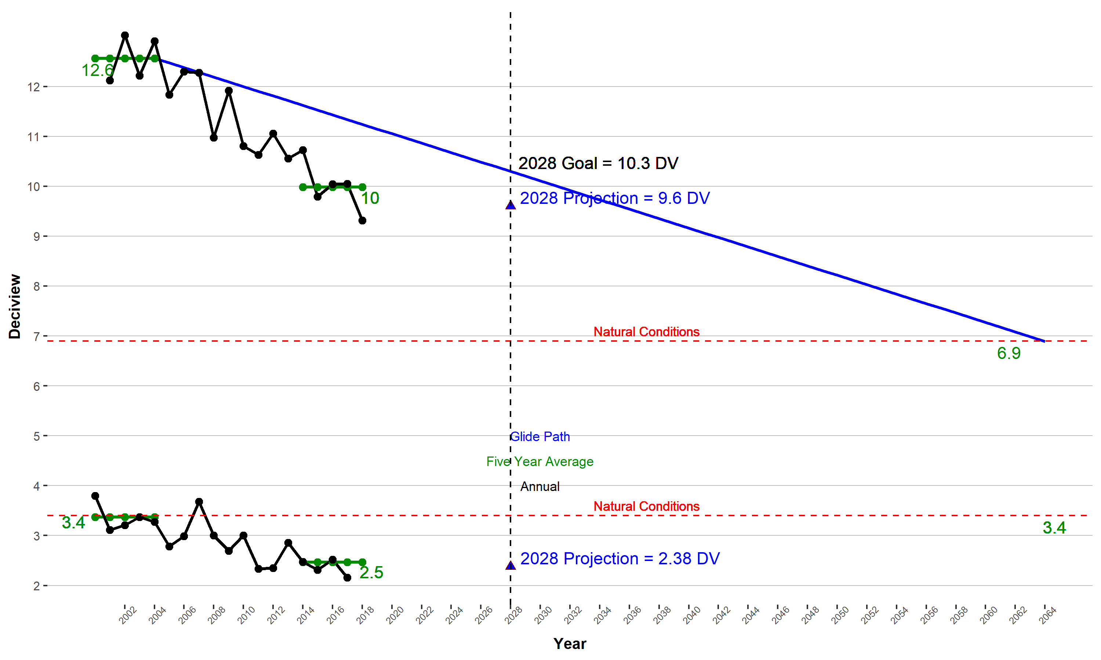
Figure 2: Projected 2028 visibility conditions on the MID in North Cascades National Park and Glacier Peak Wilderness

Progress in reducing visibility impairing pollutants
More information coming after modeling rerun Sulfate: More information coming after modeling rerun
Organic Matter Carbon: More information coming after modeling rerun
Nitrate: More information coming after modeling rerun
Summary: More information coming after modeling rerun

2018 reasonable progress goal for the MID
Ecology concludes that 9.6 dv is the 2028 RPG for North Cascades National Park and Glacier Peak Wilderness.

Clearest days
The monitored 2000-2004 baseline conditions at NOCA on the clearest days are 3.4 dv. This second SIP covers the 2018 - 2028 period. WRAP modeling projects 2028 visibility of 2.38 dv (Figure 2).

Alpine Lakes Wilderness

Most impaired days

Baseline and projected visibility
Visibility conditions at Alpine Lakes Wilderness are monitored at the IMPROVE site SNPA1. The monitored 2000-2004 baseline conditions at this site on the MID are 15.4 dv and calculated natural conditions are 7.3 dv, a difference of 8.1 dv. The 2028 RPG is projected to be 11.8 dv, which is a visibility improvement of 3.6 dv from the baseline. The uniform rate of progress or glidepath value to natural conditions in 2064 is 12.1 dv in 2028.
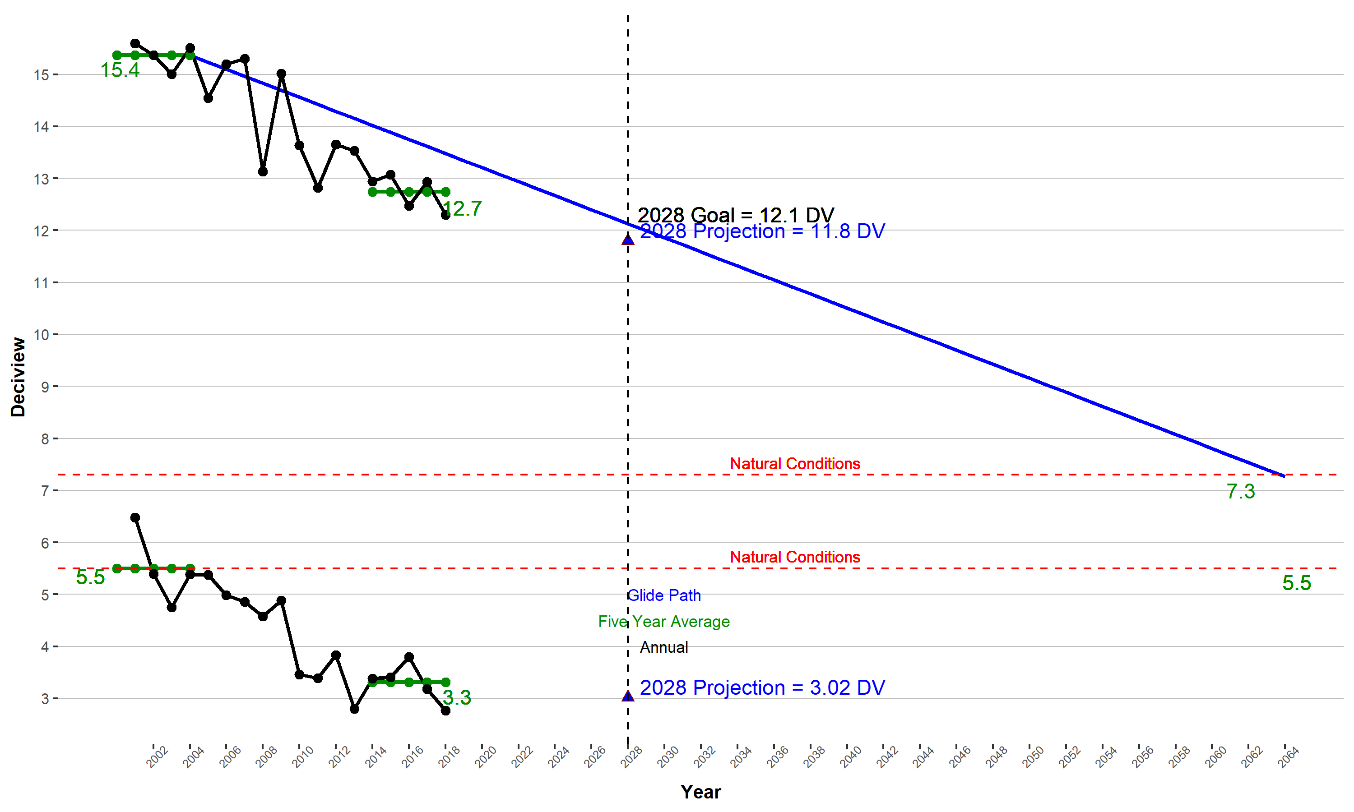
Figure 3: Projected 2028 visibility conditions on the MID in Alpine Lakes Wilderness
Progress in reducing visibility impairing pollutants
More information coming after modeling rerun
Sulfate: More information coming after modeling rerun
Organic Matter Carbon More information coming after modeling rerun
Nitrate More information coming after modeling rerun
Summary: Ecology concludes from this analysis that Washington is making progress in reducing visibility impairing pollutants impacting Alpine Lakes Wilderness.

2028 reasonable progress goal for the MID
Ecology concludes that 11.8 dv is the 2028 MID RPG for Alpine Lakes Wilderness with the controls on the books.

Clearest days
The monitored 2000-2004 baseline conditions at SNPA on the clearest Ddays are 5.5 dv. This second SIP covers the 2018 - 2028 period. WRAP modeling projects 2028 visibility of 3.0 dv (Figure 3).

Mount Rainier National Park

Most impaired days

Baseline and projected visibility

Visibility conditions at Mount Rainier National Park are monitored at the IMPROVE site MORA1. The monitored 2000-2004 baseline conditions at this site on the MID are 16.5 dv and calculated natural conditions are 7.7 dv, a difference of 8.8 dv. This second RH SIP covers the second implementation period, 2018 to 2028. WRAP modeling projects a 2028 visibility RPG of 11.9 dv which is 4.6 dv less than the baseline. The uniform rate of progress or glidepath value to natural conditions in 2064 is 13.0 dv in 2028.
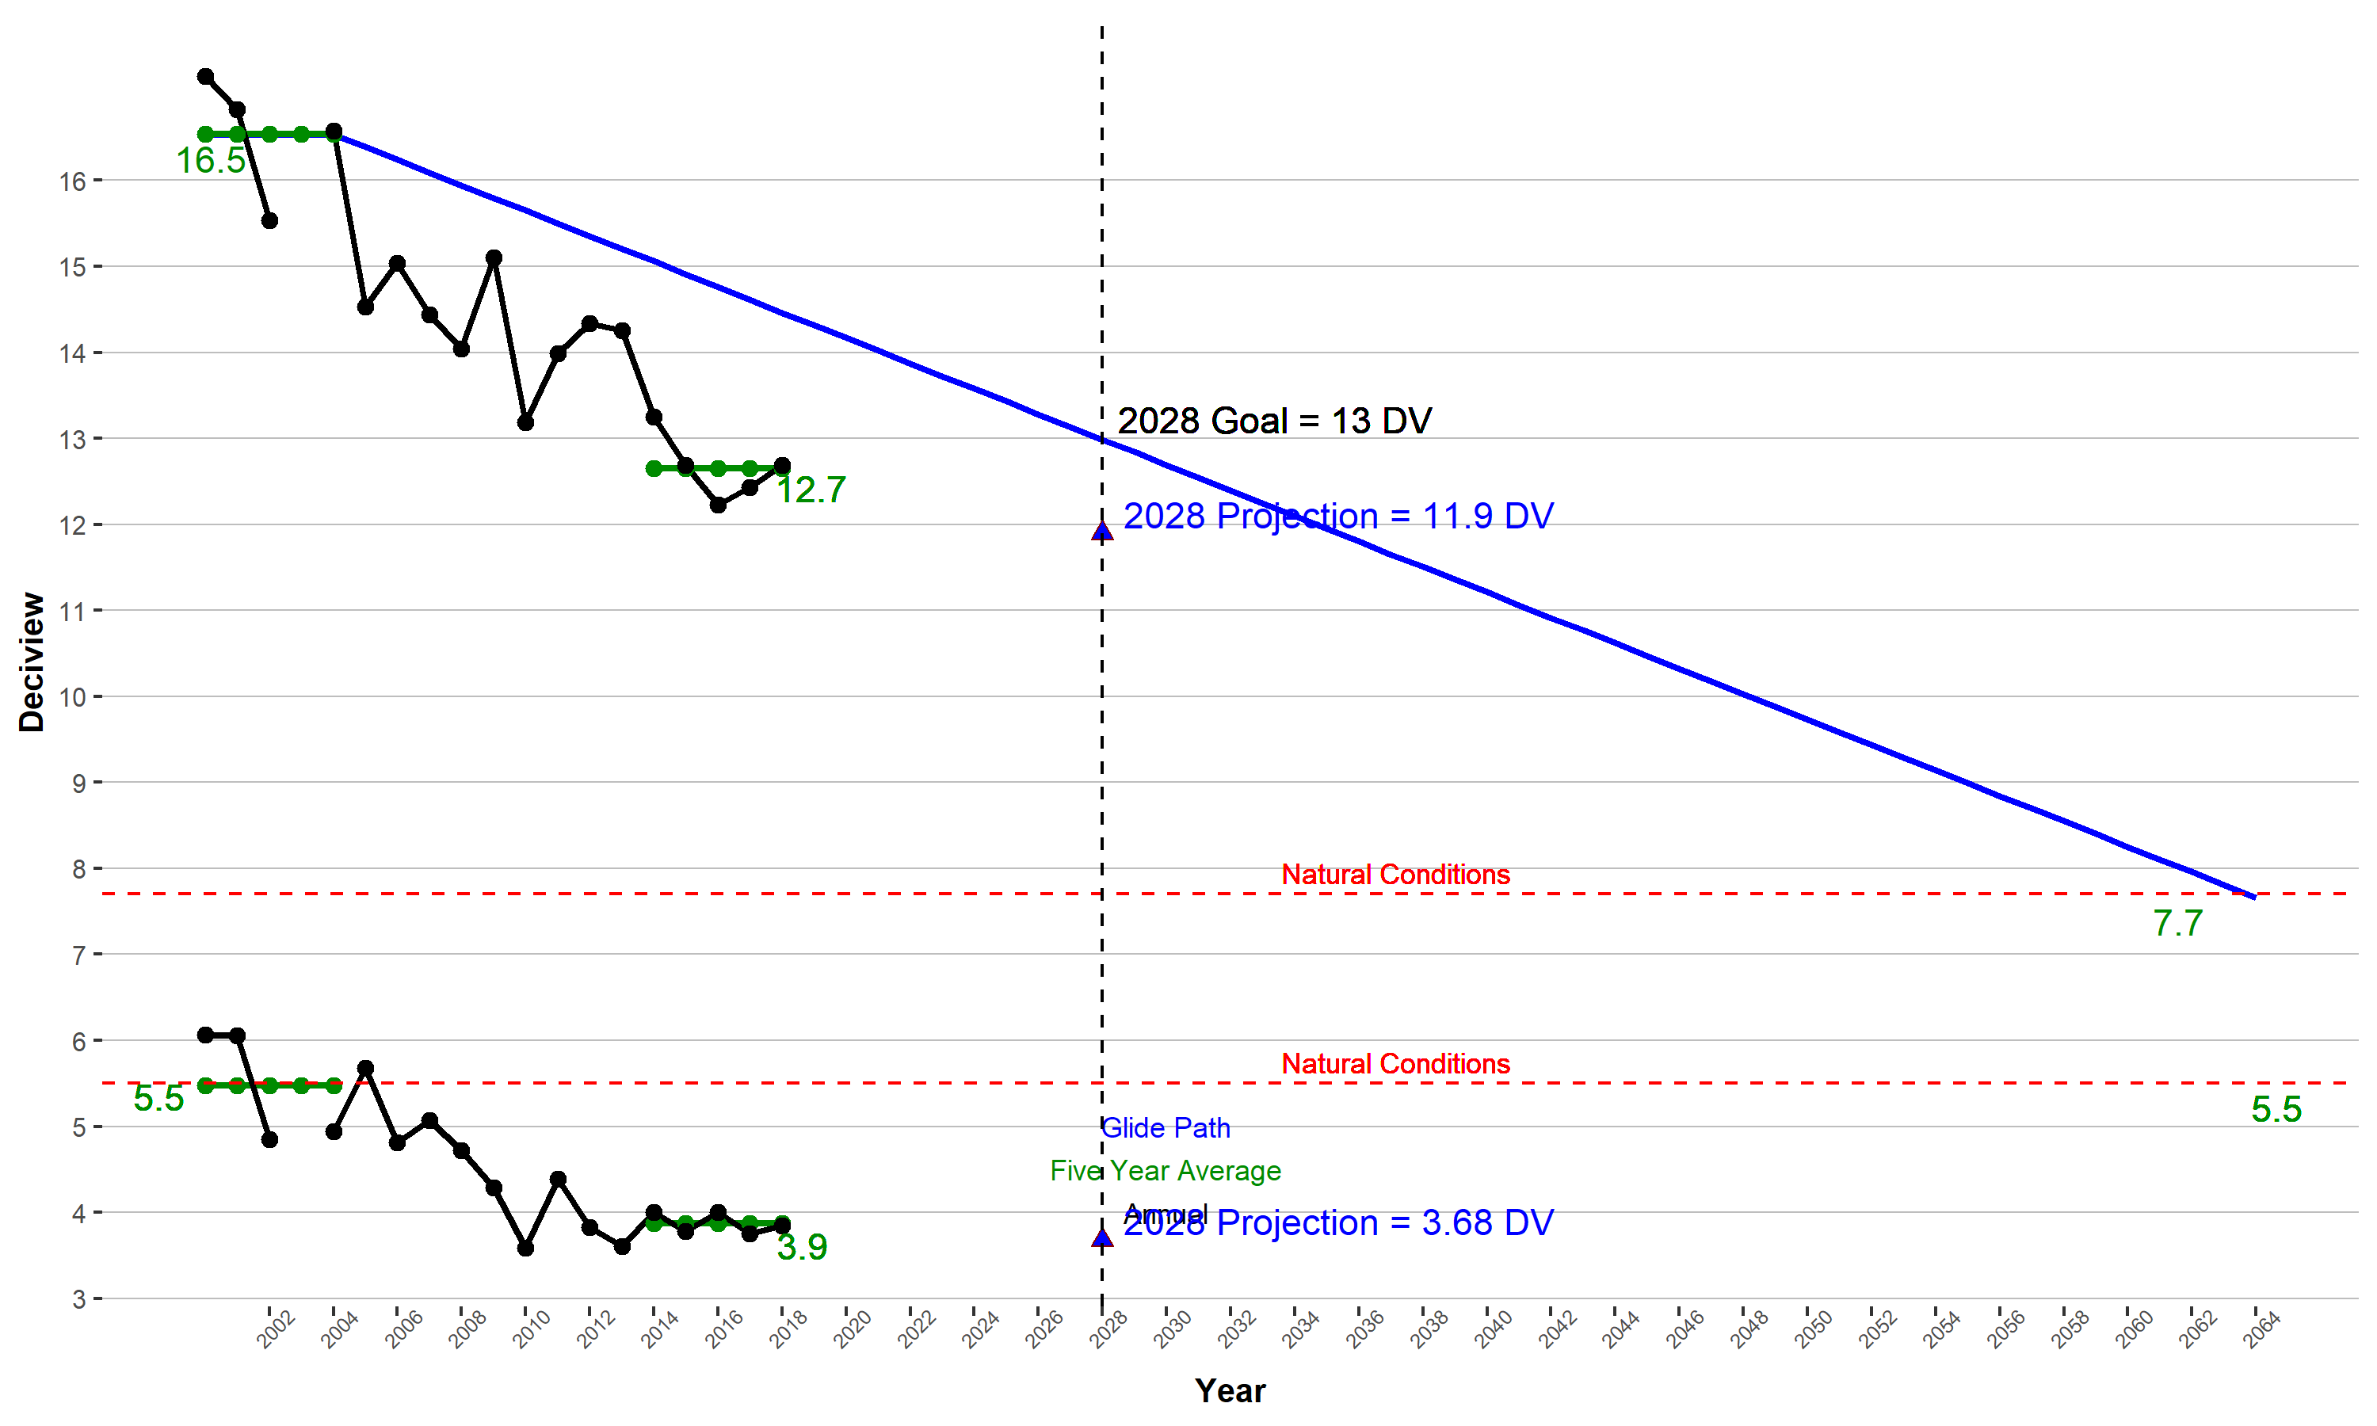
Figure 4: Projected 2028 visibility conditions on the MID in Mount Rainier National Park

Progress in reducing visibility impairing pollutants
More information coming after modeling rerun
Sulfate: 2028 modeling projects a reduction in the extinction coefficient for sulfate from 23.7 to 18.55 Mm⁻¹, a visibility improvement of 5.15 Mm⁻¹. Adherence to the uniform glide path would result in a 2028 extinction coefficient for sulfate of 16.58 Mm⁻¹.
Statewide emissions of SO₂ are projected to decline almost 40% between the 2000-2004 baseline period and 2028. Basically this decline results from a 29% reduction in point source emissions and a 95% reduction in on-road and off-road mobile source emissions. The mobile source reduction reflects the removal of sulfur from on-road and off-road fuels.
More information coming after modeling rerun
Organic Matter Carbon:
More information coming after modeling rerun
Nitrate: More information coming after modeling rerun
Summary: Ecology concludes from this analysis that overall Washington is making progress in reducing visibility impairing pollutants impacting Mount Rainier National Park. Ecology relied on a four-factor analysis to address this issue.

2028 reasonable progress goal for the MID
Ecology concludes that 11.9 dv is the 2028 MID RPG for Mount Rainier National Park.

Clearest days
The monitored 2000-2004 baseline conditions at MORA on the clearest days are 5.5 dv. This second SIP covers 2018 to 2028. WRAP modeling projects 2028 visibility of 3.68 dv (Figure 4).

Goat Rocks Wilderness and Mount Adams Wilderness

Most impaired days

Baseline and projected visibility
Visibility conditions at Goat Rocks Wilderness and Mount Adams Wilderness are monitored at the IMPROVE site WHPA1. The monitored 2000-2004 baseline conditions at this site on the MID are 10.5 dv and calculated natural conditions are 6.1 dv, a difference of 4.4 dv. WRAP modeling projects 2028 visibility RPG of 7.5 dv which is 3.0 dv less than the baseline. The uniform rate of progress or glidepath value to natural conditions in 2064 is 8.7 dv in 2028.
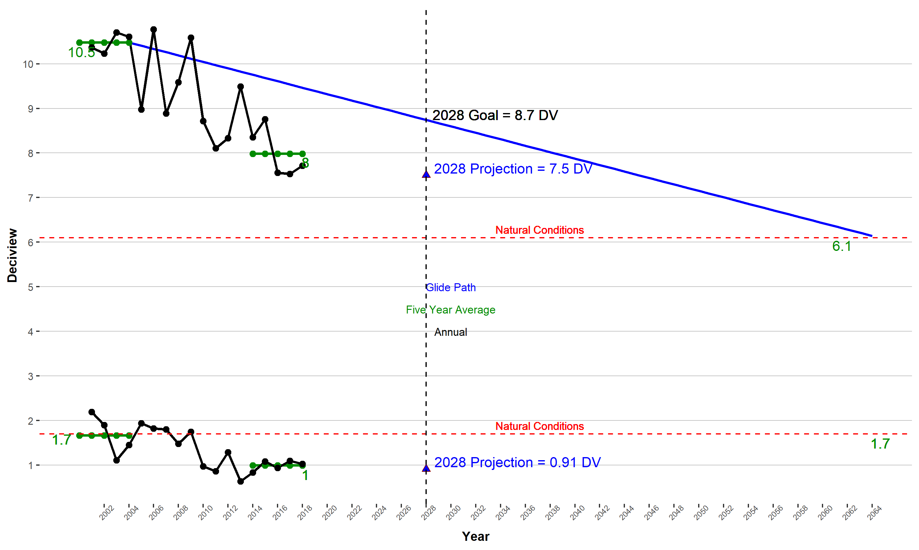
Figure 5: Projected 2028 Visibility Conditions on the MID in Goat Rocks Wilderness and Mount Adams Wilderness

Progress in reducing visibility impairing pollutants
More information coming after modeling rerun
Sulfate:More information coming after modeling rerun
Organic Matter Carbon: More information coming after modeling rerun
Nitrate: More information coming after modeling rerun
Summary: Ecology concludes from this analysis that overall Washington is making progress in reducing visibility impairing pollutants impacting Goat Rocks Wilderness and Mount Adams Wilderness. Ecology relied on a four-factor analysis in this conclusion.

2028 reasonable progress goal for the MID
Ecology concludes that 7.5 dv is the 2028 RPG for Goat Rocks Wilderness and Mount Adams Wilderness with the controls on the books.

Clearest days
The monitored 2000-2004 baseline conditions at WHPA on the clearest days are 1.7 dv. This second SIP covers the 2018 - 2028 period. WRAP modeling projects 2028 visibility of 0.91 dv (Figure 5).

Pasayten Wilderness

Most impaired days

Baseline and projected visibility
Visibility conditions at Pasayten Wilderness are monitored at the IMPROVE site PASA1. The monitored 2000-2004 baseline visibility at this site on the MID is 10.4 dv and calculated natural conditions are 6 dv, a difference of 4.4 dv.
WRAP modeling projects 2028 visibility RPG of 9.1 dv which is 1.3 dv less than the baseline. The uniform rate of progress or glidepath value to natural conditions in 2064 is 8.6 dv in 2028. The 2028 projected dv level is above the glidepath so more analysis is required for Pasayten Wilderness.

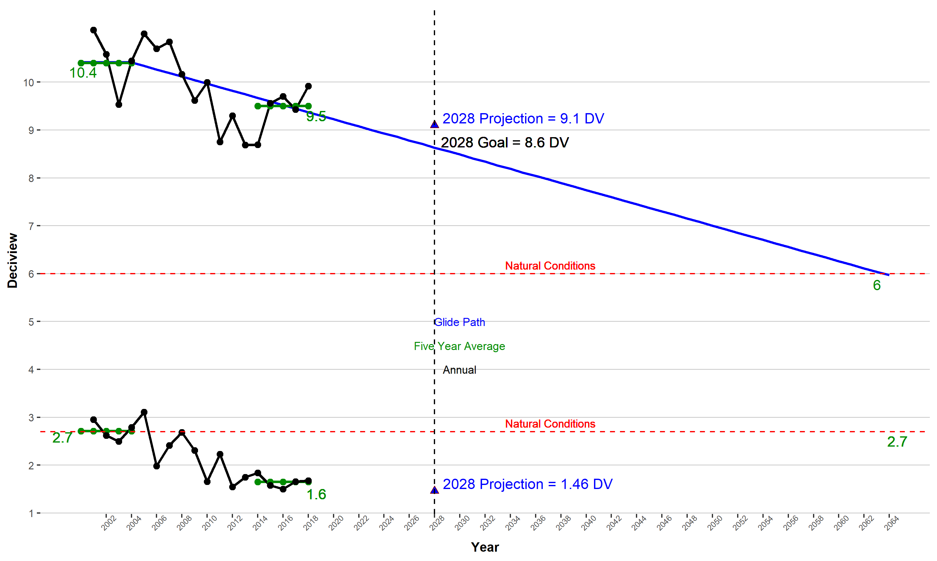
Figure 6: Projected 2028 visibility conditions on the MID in Pasayten Wilderness
Sulfate: More information coming after modeling rerun
Organic Matter Carbon More information coming after modeling rerun
Elemental Carbon: More information coming after modeling rerun
Nitrate More information coming after modeling rerun
Summary: Ecology concludes from the analysis provided above that overall Washington is making progress in reducing visibility impairing pollutants impacting Pasayten Wilderness. At the same time Ecology acknowledges some ambiguity exists with regard to projected 2028 visibility at Pasayten Wilderness.

2018 reasonable progress goal for the MID
Ecology concludes that the 2028 RPG for Pasayten Wilderness of 9.1 dv requires further evaluation.

Clearest days
The monitored 2000-2004 baseline conditions at PASA on the clearest days are 2.7 dv. This second SIP covers the 2018 - 2028 period. WRAP modeling projects 2028 visibility of 1.46 dv (Figure 6).

Summary
Ecology established RPG, in deciviews, for the MID and the Clearest Days as required by the RHR. These are summarized in Table 1.
Table 1: 2028 reasonable progress goals in deciviews (dv) for the MID
Mandatory Class I Areas | 2000-2004 Baseline Conditions | Reasonable Progress Goal 2028 | Glidepath 2028
Olympic National Park | 14.9 | 11.4 | 11.7
North Cascades National Park & Glacier Peak Wilderness | 12.6 | 9.6 | 10.3
Alpine Lakes Wilderness | 15.4 | 11.8 | 12.1
Mount Rainier National Park | 16.5 | 11.9 | 13
Goat Rocks Wilderness & Mount Adams Wilderness | 10.5 | 7.5 | 8.7
Pasayten Wilderness (more evaluation needed) | 10.4 | 9.1 | 8.6

Table 2: 2028 projections in deciviews (dv) for the clearest days
Mandatory Class I Areas | 2000-2004 Baseline Conditions | 2028 projection
Olympic National Park | 6 | 3.37
North Cascades National Park & Glacier Peak Wilderness | 3.4 | 2.38
Alpine Lakes Wilderness | 5.5 | 3.03
Mount Rainier National Park | 5.5 | 3.68
Goat Rocks Wilderness & Mount Adams Wilderness | 1.7 | 0.91
Pasayten Wilderness | 2.7 | 1.46

In establishing RPG for the MID, Ecology considered controls on the books and impact of out-of-state emissions.
Ecology’s analysis of the state’s Class I Areas determined that emissions from Canada play a significant role. Likewise, Pacific offshore emissions play a significant role in all mandatory Class I Areas except Pasayten Wilderness.
Three mandatory Class I Areas — North Cascades National Park, Glacier Peak Wilderness, and Pasayten Wilderness — are significantly impacted by prescribed fire. WRAP’s analysis projected baseline period fire emissions to 2028 without any change. If such projections are assumed to be reasonable estimates of the impacts of fire in 2028, the magnitude of fire impacts are very large and natural conditions may need to be reinterpreted to allow for increased smoke impacts.
Under the RHR, RPG for the clearest days are required to ensure no degradation of visibility. Ecology set the RPG at baseline visibility conditions. The WRAP’s modeling analysis indicates these goals will be met.

