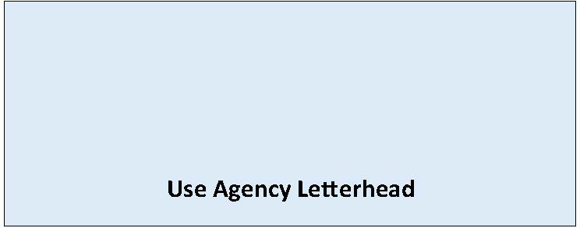

State Environmental Policy Act

Notice of Assumption of Lead Agency Status
Date of Issuance: [Enter date]
Title and Description of Proposal: [Enter name and description of proposal]
Proponent: [Enter applicant name]
Location of Proposal: [Enter location of proposal]
Initial Lead Agency: [Enter initial lead agency]
New Lead Agency: [Enter new lead agency]
The initial lead agency concluded that this proposal was not likely to have significant adverse impact on the environment, according to its Determination of Nonsignificance and Environmental Checklist of: [Enter DNS date of issuance].
We have reviewed the environmental checklist and related information. In our opinion, an environmental impact statement (EIS) is required on the proposal, because of the following impacts:
[List likely probable significant environmental impacts, areas of study, existing studies and reports, proposed methods of analysis and other background information.]
You are being notified that we assume the responsibility of lead agency under SEPA, including the duty to prepare an EIS on the proposal. Please contact [Enter staff contact for SEPA review] at [Enter staff contact information, e.g. email/phone] for additional information.
Responsible Official: [Enter name of responsible official]
Position/Title: [Enter position or title if responsible official]
Address: [Enter agency address]
Phone: [Enter phone number of contact person or responsible official]
Email: [Enter email]

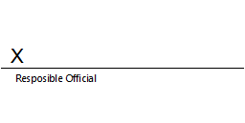
Signature Date: [Enter date]

