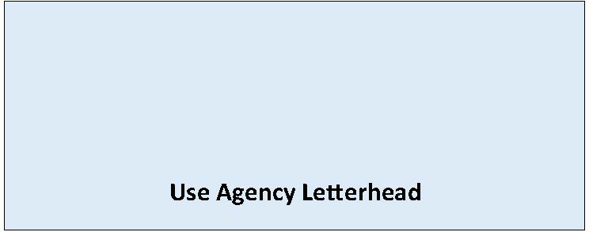

State Environmental Policy Act

[Choose One: DNS or MDNS]

Adoption of Existing Document

Date of Issuance: [Enter date]
Description of current proposal: [Enter name and description of the proposal. The proposal is the total scope of the project it is not limited to only a description of the lead agency’s permit decision.]
Proponent: [Enter name, phone, email of Applicant/Proponent]
Location of current proposal: [Enter address, parcel number, or other identifying information]
Title of document being adopted: [Enter document title(s)]
Agency that prepared document being adopted: [Enter agency name]
Date adopted document was prepared: [Enter date]
Description of document (or portion) being adopted: [Enter description of document being adopted]
If the document being adopted has been challenged (WAC 197-11-630), please describe: [Describe appeal, if applicable]
The document is available to be read at: [Enter document link]
[Enter lead agency] has identified and adopted this document as being appropriate for this proposal after independent review. The document(s) meet(s) our environmental review needs for the current proposal and will accompany the proposal to the decision maker(s).
We have determined that this proposal will not have a probable significant adverse impact on the environment. An environmental impact statement (EIS) is not required under RCW 43.21C.030(2)(c). This determination is based on the following findings and conclusions:
[Enter rationale for non-significance, e.g. mitigation measures in required permits addressing potential impacts with a summary of permit conditions etc. If MDNS list proposed mitigation.]
Name of agency adopting document: [Enter your agency name]
Contact person, if other than responsible official: [Enter name of primary staff contact person for this proposal]
Phone: [Enter phone number of contact person]
Email: [Enter email of contact person]
☐ There is no comment period for this DNS Adoption.
☐ This DNS Adoption is issued after using the optional process in WAC 197-11-355. There is no further comment period on this DNS Adoption.
☐ This DNS Adoption is issued under WAC 197-11-340(2); the lead agency will not act on this proposal for 14 days from the date of issuance. Comments must be submitted by: [Enter date and time comments due].

Responsible Official: [Enter name of SEPA responsible official]
Position/Title: [Enter position or title of SEPA responsible official]
Address: [Enter agency address]
Phone: [Enter phone number of responsible official]
Email: [Enter email]
Signature:
Signature Date: [Enter date]
(Optional)
☐ You may appeal this determination to [name of agency] at [address of agency] no later than [Enter date of appeal deadline] by [method of filing appeal]. You should be prepared to make specific factual objections. Contact [enter contact info] to read or ask about the procedures for SEPA appeals.
☐ There is no agency appeal.

