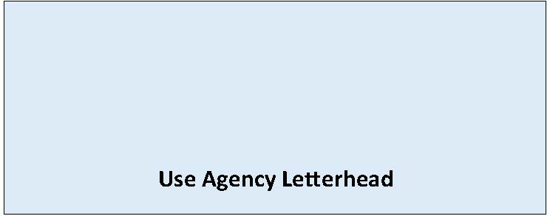

State Environmental Policy Act

Determination of Significance
Adoption of Existing Document
Date of Issuance: [Enter date]
Description of Current Proposal: [Enter name and description of the current proposal. The proposal is the total scope of the project, it is not limited to only a description of the lead agency’s permit decision.]
Proponent: [Enter name, phone, email of Applicant/Proponent]
Location of current proposal: [Enter address, parcel number, or other identifying information]
Title of document being adopted: [Enter document title]
Agency that prepared document being adopted: [Enter agency name]
Date adopted document was prepared: [Enter date]
Description of document (or portion) being adopted: [Include the lead agency, scope of review, and if the document has been appealed]
If the document being adopted has been challenged (WAC 197-11-630), please describe: [Describe challenge, if applicable]
The document is available at: [Enter document link]
[Lead agency] has determined that this proposal is likely to have a significant adverse impact on the environment. We have identified and adopted this document as being appropriate for this proposal after independent review. The document(s) meet(s) our environmental review needs for the current proposal and will accompany the proposal to the decision maker(s) in lieu of preparation of a separate Environmental Impact Statement (EIS).
This Determination of Significance and Adoption Notice is issued under WAC 197-11-630(3)(a) and consequently the general EIS preparation process does not apply.
[Enter information about comment period if applicable to correspond public notice on underlying agency action - or identify there is no comment period but there will be no agency action for seven days after date of this notice.]
Name of agency adopting document: [Enter agency name]
Contact person, if other than responsible official: [Enter name of contact person, if applicable]
Phone: [Enter phone number of contact person]
Email: [Enter email of contact person]
Responsible Official: [Enter name of responsible official]
Position/Title: [Enter position or title]
Address: [Enter agency address]
Phone: [Enter phone number of responsible official]
Signature Date: [Enter date]
Appeal Process: [Enter appeal process for this DS if applicable]

