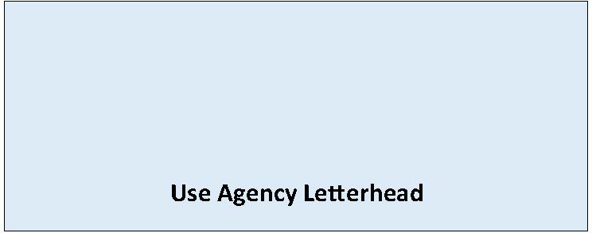

State Environmental Policy Act

Mitigated Determination of NonSignificance
Date of Issuance: [Enter date]
Lead Agency: [Enter name of lead agency]
Agency Contact: [Enter name of staff contact, email, phone]
Lead Agency File Number: [Enter lead agency file number, if applicable]
Description of Proposal: [Enter name and description of the proposal. The proposal is the total scope of the project, it is not limited to only a description of the lead agency’s permit decision.]
Applicant: [Enter name of and contact information of the proponent]
Location of Proposal: [Enter address, parcel number, or other identifying information]
The lead agency has determined that this proposal will not have a probable significant adverse impact on the environment. Pursuant to WAC 197-11-350(3), the proposal has been clarified, changed, and conditioned to include the following mitigation measures to avoid, minimize or compensate for probable significant impacts. An environmental impact statement (EIS) is not required under RCW 43.21C.030. The necessary mitigation measures are listed below, the Environmental Checklist and [Enter additional supporting document(s) if applicable] is available at [Enter webpage or document links.]
The following conditions are identified to mitigate the adverse environmental impacts of the proposal:
[List mitigation measures/conditions that will be required under SEPA. Note these conditions are in addition to mitigation required by the development regulations.]

☐ This MDNS is issued after using the optional process in WAC 197-11-355. There is no further comment period on the MDNS.
☐ This MDNS is issued under WAC 197-11-350; the lead agency will not act on this proposal for 14 days from the date of issuance. Comments must be submitted by: [Enter date and time comments due]. Submit comments to: Enter email/URL where to submit comments]

Responsible Official: [Enter name of SEPA responsible official]
Position/Title: [Enter position or title of SEPA responsible official]
Address: [Enter agency address]
Phone: [Enter phone number of responsible official]
Email: [Enter email]
Signature Date: [Enter date]
(Optional)
☐ You may appeal this determination to name of agency at [address of agency] no later than date of appeal deadline by [method of filing appeal]. You should be prepared to make specific factual objections.
☐ There is no agency appeal.

