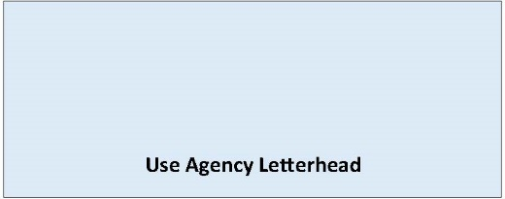

State Environmental Policy Act

Withdrawal Notice
Determination of [Enter type of threshold, e.g. DNS, MDNS, DS]
Date of Issuance: [Enter date]
Lead Agency: [Enter name of lead agency]
Agency Contact: [Enter name of staff contact]
Email: [Enter email of staff contact]
Phone Number: [Enter phone number of staff contact]
Agency File Number: [Enter agency file number, if applicable]
[Enter name and description of proposal – proposal is the total scope of the project or non-project, it is not limited to a description of the lead agency’s permit decision]
Proposal Location: [Enter proposal location address, parcel number and/or latitude-longitude if available]
Applicant/Proponent: [Enter name of applicant/proponent]
Email: [Enter email of applicant/proponent]
Phone Number: [Enter phone number of applicant/proponent]
[Lead Agency] is withdrawing the SEPA threshold [Enter the type of determination being withdrawn, e.g. DNS, MDNS, DS] issued on [Enter date of issuance of threshold being withdrawn]. If a new threshold determination is issued a new notice and comment period will be provided.
Signature Date: [Enter date]

