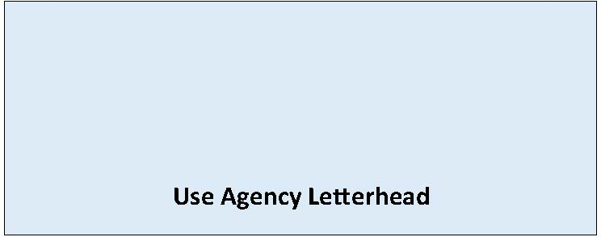

State Environmental Policy Act

Modified [Choose One: Determination of NonSignificance or Mitigated Determination of NonSignificance]

Date of Issuance: [Enter date]
Lead Agency: [Enter name of lead agency]
Agency Contact: [Enter name of staff contact, email, phone]
Lead Agency File Number: [If applicable, enter agency file number]
Applicant: [Enter name of proponent and contact information ]
Description of Proposal: [Enter name and description of the proposal. The proposal is the total scope of the project, it is not limited to only a description of the lead agency’s permit decision.]
Proposal Location: [Enter location of proposal - address, parcel number and/or latitude-longitude if available]
[Enter lead agency name] has modified its SEPA threshold determination of NonSignificance issued on [Enter date of issuance of prior DNS] in consideration of the following changes: (also attach updated Environmental Checklist, staff report, addendum or other information)
[Enter details regarding change of proposal, new information, modification of analysis, and/or mitigation measures]
[Enter name of lead agency] has reaffirmed that this proposal will not have a probable significant adverse impact on the environment. An environmental impact statement (EIS) is not required under RCW 43.21C.030(2)(c). This decision was made after review of a completed environmental checklist and other information on file with the lead agency.
This information is available at: [Enter document link]
☐ This modified DNS is issued under WAC 197-11-340(2)(f) and does not include additional notice and comment.
☐ This modified DNS is issued after using the optional process in WAC 197-11-355. There is no further comment period on the DNS.
☐ This modified DNS is issued under WAC 197-11-340(2); the lead agency will not act on this proposal for 14 days from the date of issuance.
Comments must be submitted by: [Enter date and time comments due]
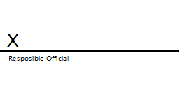
Signature Date: [Enter date]

(Optional)
☐ You may appeal this determination to [name of agency] at [address of agency] no later than [enter date of appeal deadline] by [method of filing appeal]. You should be prepared to make specific factual objections. Contact [enter contact info] to read or ask about the procedures for SEPA appeals.
☐ There is no agency appeal.

