Plan Example: (WAC 173-182-535) Planning standards for air monitoring to protect oil spill responders and the public

Purpose of these Instructions
This sample plan language is intended to assist plan holders with meeting the requirements of WAC 173-182-535. This sample plan can be used in two ways:
- As an outline to compare and update your existing plan.
- As a template to develop a new plan to send to the state.

How to Use this Document
Your plan does not need to match this sample to be approved. However, your plan must contain the necessary details and narrative which describes your capability in meeting the planning standard this sample was created for.
Your plan is a tool that should be useful to you. The suggested terminology in this boilerplate may differ from your company specific terminology. When you encounter language not typically used by your company, please substitute it with the terms you use. We are not trying to prescribe terminology in the template/boilerplate. We encourage the use of forms, tables, diagrams and checklists in your plan. In addition, pages and sections need to be replaceable when updates occur.

The following is a color coded key of additional instruction:
Non-highlighted text: The intent of non-highlighted text is to provide you with general language suggestions for your response plan. It is presented as an example of the type of information that should be included in your response plan. You can use this text as written or make changes to the text, so that it accurately describes your response capabilities and response posture.
Yellow highlighted text: Provide us your company-specific information. Where you see yellow highlights you will need to replace the text with language specific to your company.
Green highlighted text: Green highlights are used to note instructions and areas where Ecology is explaining what you need to put in your plan. This text should be deleted before you finalize your document.

When Ready to Send Ecology Your Plan:
- Remember to delete color coded text and highlights.
- Delete the instructional pages.
- Check footnotes in the document and ensure accuracy of the date and version of the plan you are submitting.
- Number your pages – your plan must have page numbers in it and they should match the page/section numbers of the rest of your plan.
- Check the table of contents carefully to ensure all pages are correctly identified.
- Complete the cross-reference table and make sure the referenced sections agree with the information location in your plan.
- Insert page breaks so that when printed you can organize the plan in a binder, separated into tabbed sections. This will also make page replacement easier when the plan is updated.
- Send us a hard copy and an electronic version. The electronic version can be sent via email to your company’s Oil Spill Preparedness Planner at Ecology. Send the hard copy to:
Ecology Spill Prevention, Preparedness & Response
PO Box 47600
Olympia, WA 98504-7600

This ends the instruction pages. The next page is the start of the sample plan.

AIR MONITORING
Airborne contaminants present a potential threat to both site workers and surrounding communities. In particular, high consequence areas (HCAs; e.g., densely populated) or sensitive groups (i.e., people with heart and lung diseases/conditions, older adults and children, hospital patients, etc.) who are at greater risk from the presence of vapors or particles in the air can be adversely impacted by such threats. As such, identification and quantification of these contaminants through air monitoring and sampling is an essential component of protecting human health.
This oil spill contingency plan is committed to following the air monitoring guidance prescribed in the NWACP and will use the tools, forms, and checklists, there within. Specifically, this contingency plan will adopt the Emergency Response Community Air Monitoring Plan (CAMP) found in section 9418-7 of the NWACP. (You may fully adopt the checklists in the NWACP, or you may use checklists that are consistent with the NWACP).
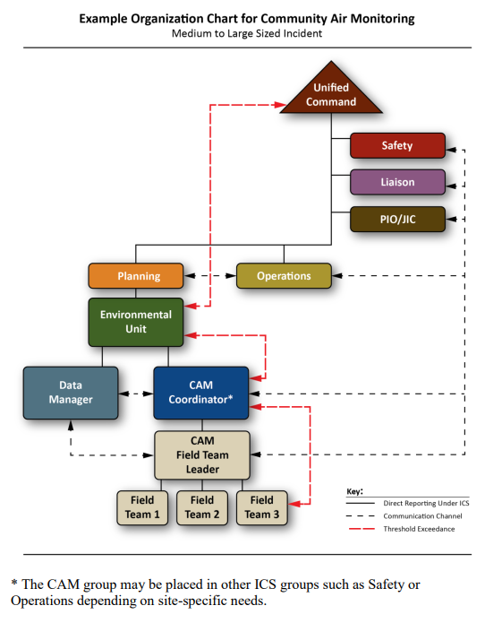

Initial site safety assessment for responders (WAC 173-182-535 (1))
[enter name of contractor or internal air monitoring team] will gather the initial information to determine if the scene is safe for responders.. The following information should be collected and immediately relayed to the Incident Command and to the Site Safety Officer:
- Location of the release source (GPS coordinates or street address)
- Location and description of any visible airborne or liquid plumes
- Meteorological information including temperature, wind speed and direction
- Air monitoring results in the breathing zone (4 to 5 feet above ground) around the perimeter of the incident (upwind, crosswind, and downwind)
- Air monitoring in low-lying areas (for dense gases and/or heavier-than-air vapor)
- Identification and location of potential community receptors such as homes, businesses, schools, government buildings, day cares, retirement homes, churches, prisons, etc.
- Air monitoring results between the incident site and these community receptor locations
(Instead of, or in addition to, a bullet list (above), it would be appropriate here to refer to the form/document you use to document initial site assessment and air monitoring results).

Work area air monitoring (WAC 173-182-535 (2))
Upon completion of initial site characterization, [enter name of contractor or internal air monitoring team] will continue air monitoring for responder safety within work areas.

Community air monitoring (area wide monitoring) (WAC 173-182-535 (3))
Area wide community air monitoring (CAM) will occur in accordance with the incident specific CAMP and at the direction of the CAM Coordinator and Unified Command. In general, real-time fixed and roving air monitors will be deployed; data reporting practices, criteria, and frequency will be issued. If an exceedance occurs, CAM personnel should ensure that UC is notified immediately through the CAM Coordinator and/or the Environmental Unit Leader.

Air monitoring instruments and detection limits (WAC 173-182-535 (4))
[Enter name of contractor or internal air monitoring team] will employ free-roaming handheld real-time air monitoring instruments (i.e., gas meters, colorimetric tubes, chemical sensors) to detect constituents of oil vapors and combustion products. Table 1 summarizes the instrumentation, target chemicals, and detection limits. The specific types of equipment and their locations can be found online in the Worldwide Response Resource List at www.wrrl.world. If your equipment can not be found on the WRRL, provide a reference to where it can be found.

Action levels for various oil constituents of concern based on products handled by [COMPANY NAME] (WAC 173-182-535 (5))
Following an oil or chemical release, questions often arise around the potential for community exposure to airborne contaminants. Air monitoring can be performed to evaluate whether airborne particulate matter (smoke) and/or gaseous vapor chemicals are present at levels that could potentially affect human health. The following tables describe action levels for various oil vapor constituents that could be expected to be present following a spill of the products handled by [Company Name].
Please include and/or refer to the Action Level tables in NWACP Section 9418

Data management protocols and reporting time frames to the unified command (WAC 173-182-535 (6))
Data management protocols and reporting time frames will be established by the CAM Coordinator with direction from the Environmental Unit Leader, Safety Officer and Unified Command. These data management protocols and reporting time frames will be documented in the Emergency Response CAMP in accordance with NWACP 9418. If an exceedance occurs, CAM personnel should ensure that UC is notified immediately through the CAM Coordinator and/or the Environmental Unit Leader.
Please include and/or refer to the Data Sources and Data Management tables in NWACP Section 9418

Communication methods to at-risk populations (WAC 173-182-535 (7))
Information will be provided to the public and ‘at-risk’ populations at the direction of the Incident Commander or Unified Command using agreed-upon communication protocols developed by the CAM Coordinator, Site Safety Officer, Public Information Officer, and Liaison Officer. Relevant sections of the NWACP, including those on PIO and Liaison communication tools, will be referenced and used as appropriate.

Evacuation zones and shelter-in-place criteria (WAC 173-182-535 (8))
Evacuation zones and shelter-in-place criteria will be determined using DOT Emergency Response Guidebook, local and state criteria, EPA guidelines, initial site assessment data, or other resources. If an evacuation or shelter-in-place order is issued, site activities and air monitoring data will be continuously collected and evaluated until readings are consistently at or below safe levels. At such point, and if conditions are not expected to worsen, the lifting of evacuation/shelter-in-place orders may be recommended to the Unified Command. If warranted, local authorities may arrive on scene and initiate evacuations ahead of a formal UC being stood up.

