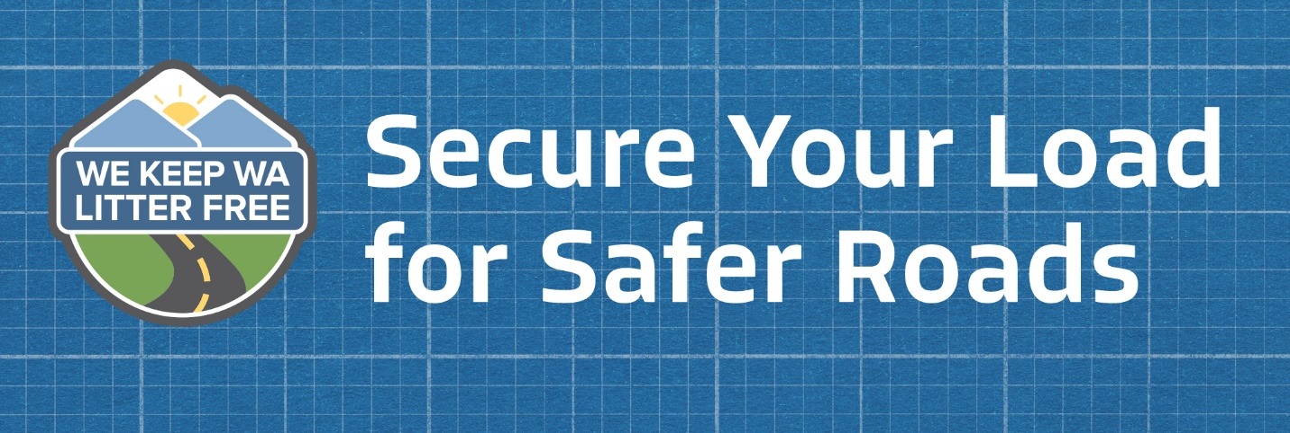

Retail Outreach

We are committed to engaging and educating Washington state residents to help make our roads safer and cleaner for everyone. With your help, we will educate your customers on how to safely secure loads in their vehicles around National Secure Your Load Day on June 6. To support the day, we would like to place informational signage at your store. Additionally, we are interested in [add additional outreach tactics here such as tabling or product endcaps] in order to encourage customers to properly secure loads.
Thank you for considering supporting our efforts!

Participation Overview:
Between May 24th and June 1st, someone from our organization will come and install a few 8.5”x 11” informational tear pads around the store focusing on areas that stock products that regularly need to be secured, check out areas, the loading zone and near the customer loading stations.
Each pad will have 100 sheets that give tips on safe loading practices. Using zip ties, the tear pad can be secured to most surfaces and can be easily removed once the pad has been emptied. The representative will also utilize the tear pad to educate any available store staff by conducting quick, five-minute “trainings” on the presence of the tear pad and safe loading practices. They may also take photos of freshly installed signage for internal use only. Reference sample photos are included on the back of this sheet for reference.
[Add details here if requesting any other tactics.]

Questions:
If you have any questions about the National Secure Your Load Day retail outreach, please contact [Name of outreach representative at your organization] at [email and phone number].

Sample Photos of Tear Pad Install:

