I. COVER PAGE: Sample attached

II. EXECUTIVE SUMMARY: Please fill out the template on the last 2 pages of this document and provide as Executive Summary. Executive Summary must be provided to the project manager in as an electronic Word Document in addition to being included in the Final Report.

III. OVERVIEW DESCRIPTION OF PROJECT: What was the water quality problem being addressed and generally how was this project going to do it?

IV. OUTCOME: Using the project tasks as your guide, describe what the project accomplished and how. Also what was not done and why? WHAT ARE THE WATER QUALITY BENEFITS? Also, include any Quality Assurance data from your monitoring activities. (Please indicate if any of the items discussed were not directly funded by the Department of Ecology Water Quality Program funding programs.) Use numbers and/or specific examples if possible.
- The discussion should include information on the following:
- Water Quality and Environmental Outcomes: anticipated water quality and environmental goals and improvements from the project. Please include types and amounts of BMPs that were installed, and the water quality parameters addressed and improvements to these parameters that will occur as a result of the project. Also, please include cumulative load reduction estimates for nitrogen phosphorus and sediment generated for all BMPs installed and any water quality improvements that were measured from water quality monitoring (if monitoring was included as part of the project).

- Performance Items and Deliverables: the action items that played an integral role in implementation of the project. This includes items such as outreach and education, monitoring, technical assistance (farm plans, nutrient management plans, etc.), GIS mapping, and others.

V. EVALUATION: Why was the project successful or unsuccessful? What is the significance of the project's outcome(s).

VI. FOLLOW-UP: What remains to be done and how will it be accomplished? Will the project be continued with or without grant funding? When do you expect to have observable/measurable water quality improvements as a result of this project? What will be done in order to maintain the project after the funding period has ended?

VII. GENERAL COMMENTS: Optional, if you have comments that do not fit easily into the above categories.
- Include Recipient's name, and Agreement Number at top of each page following the cover page.
- Number pages at bottom

Updated 5/2011
(SUGGESTED FORMAT FOR FINAL PROJECT REPORT COVER PAGE)

FINAL PROJECT REPORT

FOR

“Application Number” “Agreement Number”

“Name of Project”

“Recipient's Name”

Total Cost of Project: $
Grant or Loan Amount: $

Project Start Date:
End Date:

_________________ &/or ________________
(AUTHORIZED SIGNATORY) DATE (PROJECT MANAGER) DATE


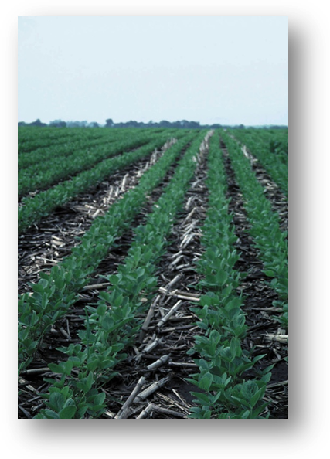
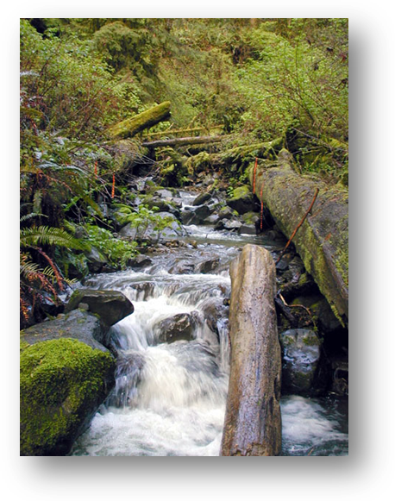
[Project Title]
[Recipient]
[Grant Number]
[Project open and close dates]
Final Total Project Cost: $
Final Ecology Grant Contribution: $

Project Description
Including water quality problem, and what the project was to accomplish.
Project Accomplishments
Provide a narrative and/or list of specific activities that were implemented by the project including, BMPs, outreach and education, and other deliverables. Include project partners.
Picture Description
Picture Description
Picture Description
Insert picture here
Insert picture here
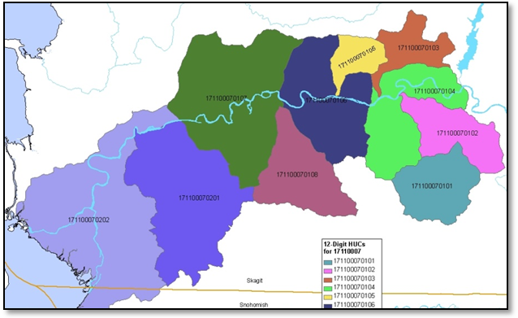
Water Quality Improvements
Discuss real and anticipated water quality improvements as a result of the project

The Next Step for Continued Success
Discuss what else needs to be done in order to improve water quality to meet water quality standards, TMDLs goals, etc.

Lessons Learned
Discuss any notable and unexpected successes or challenges, if any

Recipient Contact Information

Project Map caption
Insert project map here

