Instruction Sheet for Recipients

Process: Uploading Documents

System Status: Various statuses in the system allow the ability to upload documents.

Where can I upload documents?

Parent Document – the general “Uploads” form available to all roles and located at the botton of the “Application Forms” section. Upload deliverables or other documents required by your scope of work or funding opportunity.

Sub-documents – the “upload” field or form within a Payment Request/Progress Report, Equipment Purchase Report, and Recipient Closeout Report forms. These sub-documents are located under “Examine Related Items” in the parent document menu. Upload supporting documentation related to the sub-document.

Note: Each Ecology funding opportunity will have guidance for type of documents to upload and their preferred locations. If you are unsure of where documentation should be uploaded, please contact your Financial Manager.

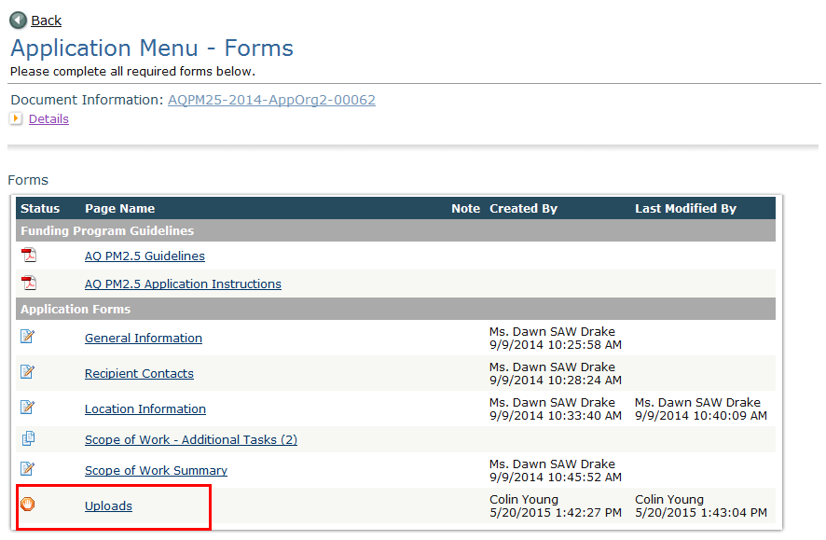

How to upload a document:

Identify where you need to upload documents in EAGL and navigate to that form.

Collect and save documents in an electronic format; scan document(s) if necessary.

Scroll to the very bottom of the list of uploaded documents for a blank field to be sure that the document you are uploading is not overwriting a previously uploaded document.
- Click “Browse,” find your saved document, and click “Save” in EAGL.

Does it matter what I name the electronic/scanned document?

Yes, clearly identify the document in the title and upload description field (if one appears in upload form), so that anyone can find it. Do not use any symbols or characters in the name. Each funding program may provide specific instructions on naming conventions.

Note: The use of symbols or characters (@#$%^&*) in the name of the document will break the hyperlink and the document will not get uploaded. EAGL will show a page error when a user tries to change the status of the document when this occurs.

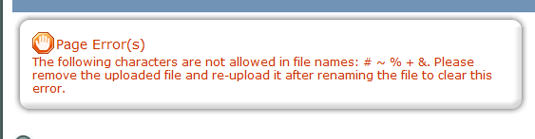

What file types can be uploaded to EAGL?

bmp, doc, gif, jpg, pdf, png, ppt, tif, txt, wpd, xls, docx, xlsx, pptx, vsd, vsdx, xml, zip, mov, avi, mp4, wmv

Is there a file size limit?

EAGL has a file size limit of 35 MB and will create an error if a user attempts to upload a larger file. However, there is no limit on the total number of files that can be uploaded.

What if my file is larger than 35MB?

Reduce the file size by any of the following:

Break a large document into a few smaller documents.

Reduce the quality of graphics or images.

When creating a PDF from Microsoft Word, use the optimization setting for minimum size.

Where can I view all the uploads within a document?

You can view all uploads associated with a parent document or a sub-document in the “Attachment Repository” found from the main menu.

To access the Attachment Repository:

From the application menu for a specific parent document or sub-document:

Click View Management Tools.

Then click Attachment Repository - Shows you which forms contain uploads and provides a direct link to the document.

Tip: View the upload file name by hovering over the hyperlink with your mouse. A URL will display the location and name of the uploaded document in status bar at the bottom of your browser.

