Instructions for Managing Recipient Roles in EAGL
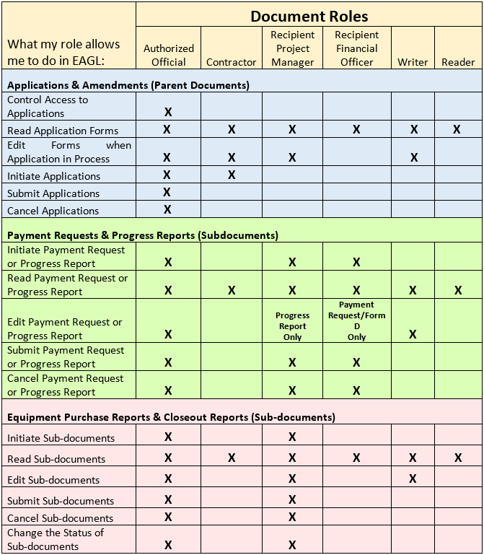

Process: Managing Organization Members and Their Roles

System Status: All

What is the Process? To manage roles/permissions at the organization, parent document and sub-document level.
 Everyone in your organization who will be doing work in EAGL must be registered in both SAW and EAGL.
Note: Do not confuse member roles with the Recipient Contacts form which is found within a parent document (Application/Agreement). This form is only used to identify contacts for a specific application and are not related to permission roles.
TIP: Additional details are available in the “Managing Roles and Permissions in EAGL” section of the EAGL User Manual.
To manage roles at the organization level:
Choose “My Organization(s)” from the “My Home” page.
Select “Organization Members” from the Organization Form.
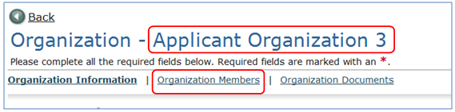
All members should have a check next to their name. The Authorized Official may now perform several actions:
- Change a member role - Select the correct role for the member from the dropdown menu and enter an active date.
- Remove a member - Enter an end date in the box below the active date.
Note: Do not uncheck! Unchecking the box next to a member’s name will delete the person from your organization and only Ecology can add them again.
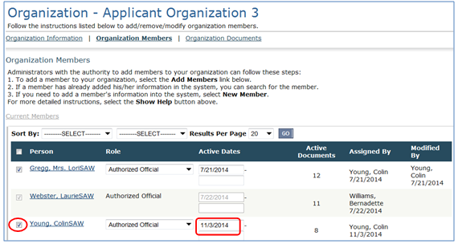

Select “SAVE” at the top right corner of the screen to save the changes.

To manage roles at the document level, the Authorized Official should:
Search for your application (parent document) through the “My Applications” or “My Organization(s)” (under Organization Documents) tab from the home screen. Click on the application number.
From the Application Menu, select “View Management Tools” located under “Access Management Tools”.

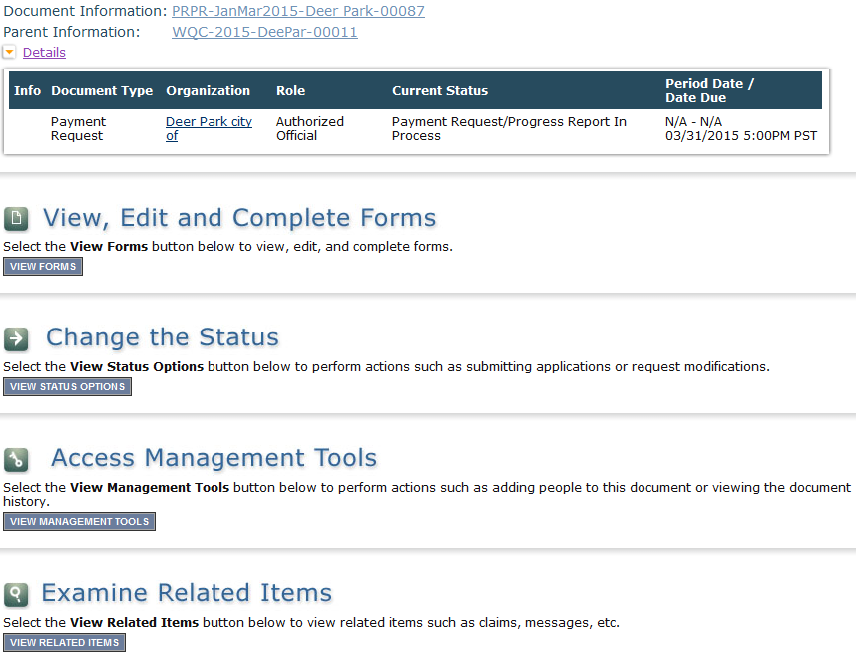
Select “Add/Edit People” and the list of current organization members will appear. The Authorized Official may now perform several actions:
- Change a member role - Select the correct role for the member from the dropdown menu and enter an active date.
- Remove a member - Enter an end date in the box below the active date.
- Add a member - Select the check box next to their name to activate their role.
Click “SAVE” at the top right corner of the screen to save the changes.

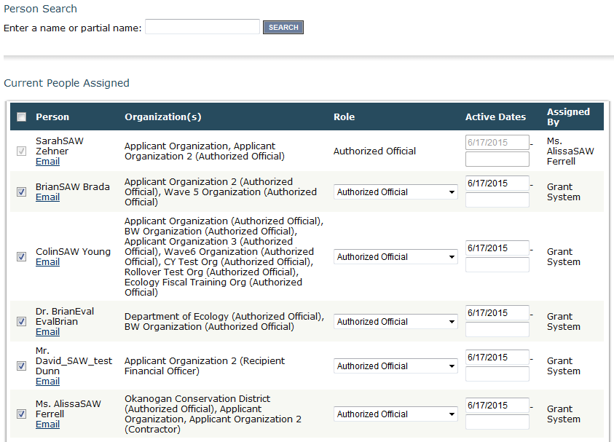

TIP: Scroll down the Add/Edit People screen to find people associated with your organization. If a member is not listed, verify that they successfully registered for SAW and EAGL.
TIP: If a document was created before a user was added to the organization, the Authorized Official will have to add the user to the document or subdocument they need access to by checking the checkbox next to their name (if it is unchecked) and click Save. Ensure the role is appropriate for permissions needed.
TIP: A person can only have one role at the document or organization level but they can be different. For example, someone who is assigned as a “Reader” at the organization level can be assigned as the “Authorized Official” on a specific document.
To manage roles at the sub-document level, the Authorized Official should:
The process is the same as above, but you find the sub-document in a different spot.
Browse to the Application Menu of the parent document. You can search by using the “My Applications” or “My Organizations” tab from the home screen.
Choose “Examine Related Items” from the Application Menu page.
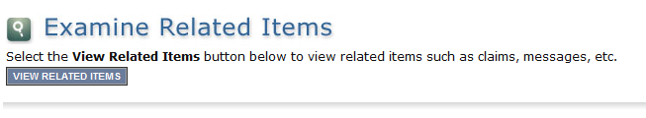
Select the appropriate sub-document to manage roles
From the sub-document’s menu, select “View Management Tools” located under “Access Management Tools”.
Select “Add/Edit People.” The Authorized Official may now perform the operations described in the previous section.
TIP: The application menu in a sub-document looks similar to that of a parent document. To ensure you are in the sub-document check the top left headings of your screen. There will be a breadcrumb hyperlink to both the “Document Information” (number of the sub-document) and its “Parent Information” (number of the parent document).

Order of Precedence
Organization Level Roles: Roles set at the organization level serve as the user’s default role on newly initiated documents.
Parent Document Level Roles: These are role assignments specific to the document and can vary from the organization role. It is important to ensure the member roles are appropriate for the access needed in the system and are actively managed for staff changes.
Sub-document Level Roles: These role assignments carry over from the parent document when initiated.
TIP: Each organization should have at least two Authorized Officials to have a back-up in case of staff turnover or unavailability.
TIP: Contractors cannot be assigned the role of Authorized Official to maintain proper internal controls related to accounting and payment request submittal. Assign a “Writer” if want to allow access to parent or subdocuments.
TIP: The Authorized Signatory is the person authorized to sign an agreement and is not to be confused with the Authorized Official role. They will not receive email notifications from EAGL. Only an Authorized Official can change role assignments.

