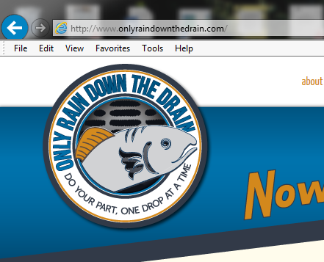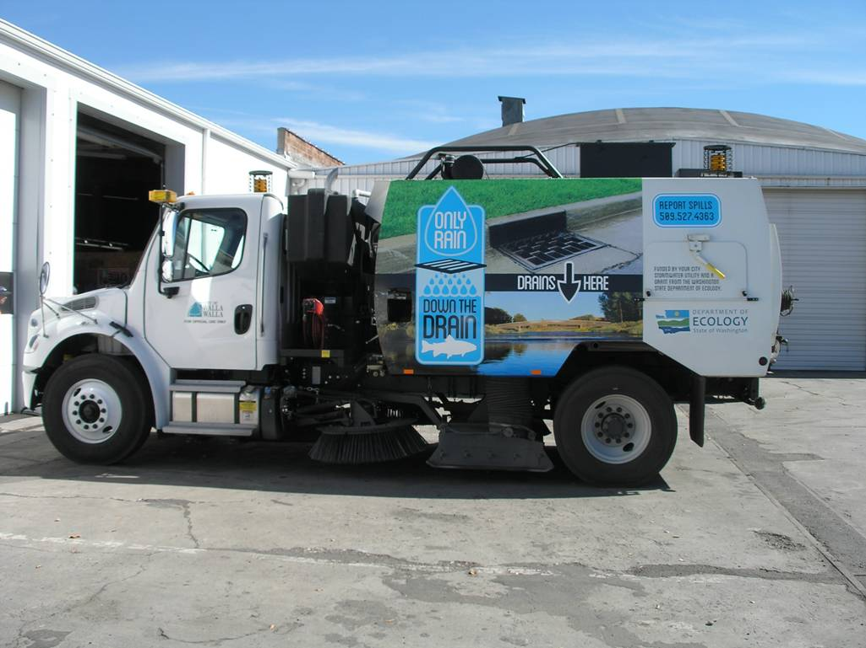ECOLOGO-C

Picture Description

**Insert picture here**

**Insert picture here**

Picture Description

**Project Description**

**[**Insert the project short description from your agreement here**]**

**[**Is this project associated with a waterbody? If yes, which?**]**

**[**Provide a brief narrative to describe why your community needed this water quality project. Describe the pre-project conditions and the water quality problem. Include information related to the problems the project will fix/help fix, such as beach closures, complaints, health hazards, citizen complaints, regulatory compliance issues, newspaper articles, ugly smelly water etc.**]**

**Project Accomplishments**

In order to improve water quality, the [Name of recipient] implemented:

Activities Implemented:

* [total #, type of activity]
* I.e. x miles of roadway swept
* I.e. x publications distributed
* I.e. x trainings hosted
* I.e. x students learned stormwater curriculum

**[**Provide a brief narrative of performance successes (*i.e. project completed on schedule and within budget),* partnerships, and other benefits.**]**

**[Project Title]**

**[Recipient]**

**[Grant or Loan Number]**

[Project open and close dates]

Final Total Project Cost: $

Ecology Funded Water Quality Improvement Cost: $

Additional Water Quality Improvement Cost: $

Other Project Cost: $

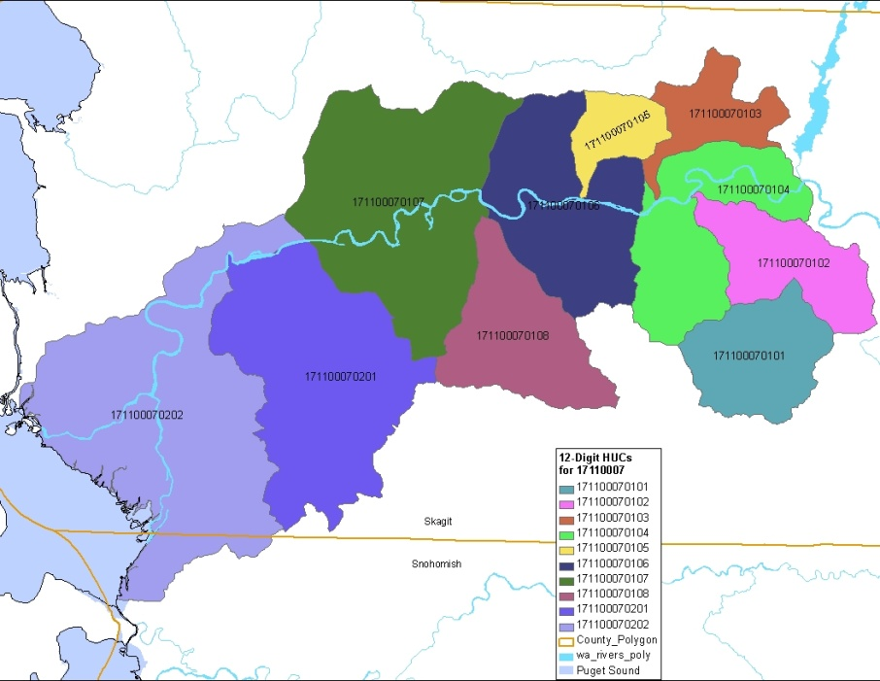

**Lessons Learned**

**[**Discuss any notable and unexpected successes or challenges**]**

**The Next Step for Continued Success**

**[**Is there more work to be done to complete this project? If so, what is the estimated time frame and will the project be continued with or without Ecology funding? If applicable, what operations and maintenance tasks will be performed and who will be performing them?**]**

**Water Quality and Environmental Outcomes**

**[**Is there any media coverage on this project? Are there any improvements to the problem described above? Mention any evidence.**]**

**[**Is this activity a requirement of the NPDES permit? If so, what permit requirement are you meeting?**]**

**[**What future outcomes do you hope to see from the project?**]**

**Insert project map here**

**Recipient Contact Information**

Project web page found [here]

Project Map caption