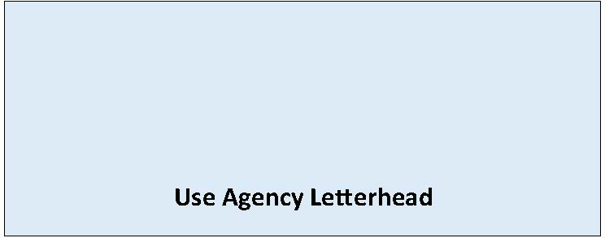

State Environmental Policy Act

Determination of NonSignificance
Date of Issuance: [Enter date]
Lead Agency: [Enter name of lead agency]
Agency Contact: [Enter name of staff contact, email, phone]
Lead Agency File Number: [Enter file number, if applicable]
Description of Proposal: [Enter name and description of the proposal. The proposal is the total scope of the project, it is not limited to only a description of the lead agency’s permit decision.]
Applicant: [Enter name of proponent and contact information]
Location of Proposal: [Enter address, parcel number, or other identifying information]
The lead agency for this proposal has determined that it does not have a probable significant adverse impact on the environment. An environmental impact statement is not required under RCW 43.21C.030(2)(c). This decision was made after review of a completed environmental checklist and other information on file with the lead agency.
Optional: [Enter findings of nonsignificance supporting this determination, e.g. identify impacts and applicable regulations that mitigate impacts.]
This information is available at: [Enter webpage or document links]
☐ There is no comment period for this DNS.
☐ This DNS is issued after using the optional process in WAC 197-11-355. There is no further comment period on the DNS.
☐ This DNS is issued under WAC 197-11-340(2); the lead agency will not act on this proposal for 14 days from the date of issuance. Comments must be submitted by: [Enter date and time comments due].

Responsible Official: [Enter name of SEPA responsible official]
Position/Title: [Enter position or title of SEPA responsible official]
Address: [Enter agency address]
Phone: [Enter phone number of responsible official]
Email: [Enter email]
Signature Date: [Enter date]
(Optional)
☐ You may appeal this determination to [name of agency] at [address of agency] no later than [Enter date of appeal deadline] by [method of filing appeal]. You should be prepared to make specific factual objections. Contact [enter contact info] to read or ask about the procedures for SEPA appeals.
☐ There is no agency appeal.

