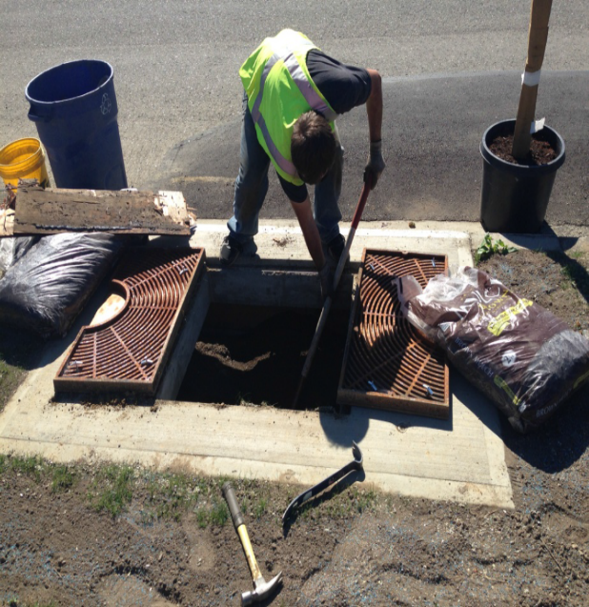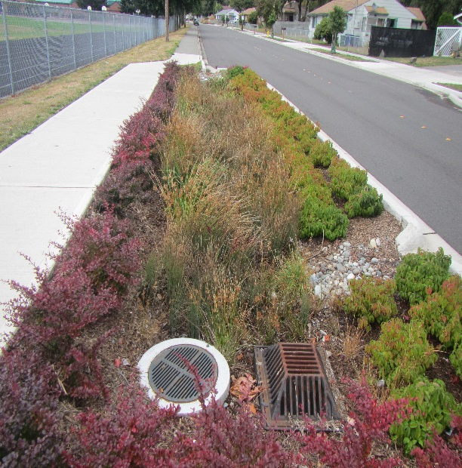ECOLOGO-C

**Insert picture here**

Picture Description

**Insert picture here**

Picture Description

**Context and Project Description**

**[**This project improves water quality in the (Name of Waterbody) through the installation of (Type of Water Quality Facilities) at (Project Location) in the (City/County) of (Name). This project provides treatment for (Total Suspended Solids (TSS), Oil (Total Petroleum Hydrocarbons), Dissolved Copper, Dissolved zinc, and Total Phosphorus) and also reduces flows to (Water Body Name) by increasing stormwater infiltration and /or providing stormwater detention. Additional benefits of this project include (list).**]**

**[**Provide a brief narrative to describe why your community needed this water quality project. Describe the pre-project conditions and the water quality problem. Include information related to the problems the project will fix/help fix, such as beach closures, complaints, health hazards, citizen complaints, regulatory compliance issues, newspaper articles, ugly smelly water etc.**]**

**Project Accomplishments**

In order to improve water quality, the [Name of recipient] installed:

Facilities Designed and/or Constructed:

* [#, type]
* Basin area [total acres draining to these facilities], [land use type]

These [BMPS] provide [flow control, source control, treatment].

**[**Provide a brief narrative of performance successes (*i.e. project completed on schedule and within budget),* partnerships, and other benefits.**]**

**[Project Title]**

**[Recipient]**

**[Grant or Loan Number]**

[Project open and close dates]

Final Total Project Cost: $

Ecology Funded Water Quality Improvement Cost: $

Additional Water Quality Improvement Cost: $

Other Project Cost: $

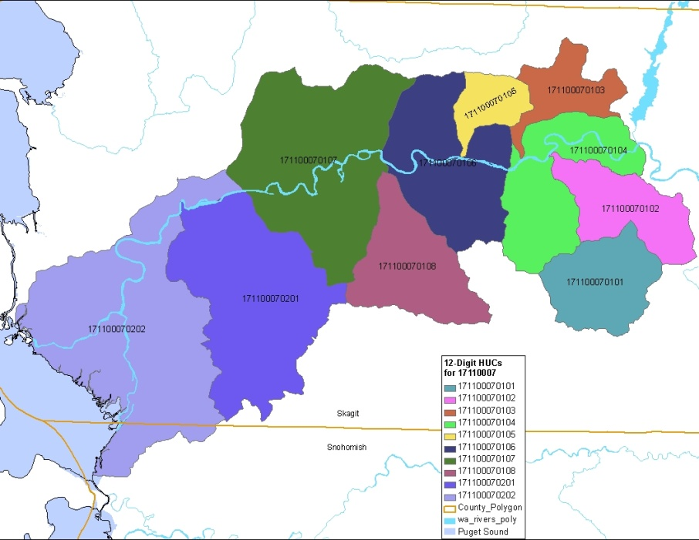

**Water Quality and Environmental Outcomes**

Evaluating water quality benefits from retrofit projects can be challenging.  Often, the existing built environment does not have enough undeveloped land left to build BMPs that would be sufficient to effectively manage all the stormwater generated by the drainage basin.  In the retrofit program, Ecology encourages local communities to build the largest facility that will fit in the available space and then uses a calculation that was developed with stakeholder input to evaluate the amount of treatment and flow control provided in retrofit projects on a common basis for reporting purposes. Ecology calls this area the runoff treatment or flow control equivalent area.

Using this equivalent area, we can estimate the amount of solids removal per year that the project can achieve, using a given amount of pollutant removal and the annual runoff. We can also estimate the area that has runoff similar to pre-developed conditions created through the retrofit project.

The following table lists the equivalent area values for this project:

|  |  |  |  |
| --- | --- | --- | --- |
|  | **Runoff Treatment** | | **Flow Control** |
| Actual Basin Area (ac) | Equivalent Area (ac) | Solids removed per year (lbs.) | Equivalent Area (ac) |
|  |  |  |  |

**[**Is there any media coverage on this project? Are there any improvements to the problem described above? Mention any evidence.**]**

**Lessons Learned**

**[**Discuss any notable and unexpected successes or challenges**]**

**The Next Step for Continued Success**

**[**Is there more work to be done to complete this project? If so, what is the estimated time frame and will the project be continued with or without Ecology funding? What operations and maintenance tasks will be performed and who will be performing them?**]**

**Insert project map here**

**Recipient Contact Information**

Project web page found [here]

Project Map caption