Floodplains by Design

2023-2025 Grant Pre-Application
Applicants are strongly encouraged to review the 2023-25 Floodplains by Design (FbD) Funding Guidelines before submitting this pre-application. Our flood team staff and the FbD Management Team will evaluate pre-applications to determine if the proposed project is consistent with the FbD grant program.
Applicants whose proposals are consistent with the program will be invited to give a presentation to reviewers during the week of Feb. 14-18, 2022. At this time, all presentations will likely be virtual. The presentation format will be available in early December. Presentations will last a half hour, with 15 minutes of Q & A with the review team.
No other attachments or materials will be accepted or reviewed at this time.
The pre-application deadline is Jan. 14, 2022

How to apply

Email your pre-application to: Scott McKinney at scott.mckinney@ecy.wa.gov with the following:
  - Email subject line: 2023-2025 FbD Project Pre-Application, (your project title)
- Project Title:
  - Organization/Jurisdiction Name:
  - Address:
  - City, State, Zip Code:
  - Contact Name:
  - Contact Phone:
  - Contact Email:
- Project Location:
  - County/Counties:
  - WRIA(s):
  - Congressional District(s)
  - Legislative District(s)
  - Major Watershed:
  - # of Reaches:
- For site-specific projects, please include: River Mile(s) and/or GPS coordinates (Latitude, Longitude), if available.

Pre-application: 2023-2025 Floodplains by Design Grant Funding
Please note: Pre-Applications must be submitted using this form, in Word or PDF format. Attach any maps requested in #5 in a single PDF. Use at least an 11-point font size.
- Project Type
Is this an individual stand-alone project, or a part of a larger multi-phase project or program? Note: Multi-phased projects or programs are not necessarily rated higher than stand-alone projects:
- Integration
Check off the current status of your integrated floodplain management efforts. This will help evaluators understand the context for your responses. There is no preferred answer. Projects will be evaluated within the context set by these responses. Please refer to the Floodplains by Design Funding Guidelines for further definition of the terms below;
  - Select the scale(s) at which integrated floodplain work is occurring that resulted in this proposal. Select all that apply:
☐Watershed
☐Reach
☐Site-specific
  - Check which integrated approach best describes your overall effort. Refer to the Funding Guidelines for further definition and description of the various types below:
☐Integrated capital project(s)
☐Integrated capital program – reach scale(s)
☐Integrated capital program – watershed scale
☐Integrated floodplain management
  - Check the boxes below in the Elements of Integrated Projects or Elements of Integrated Management section that best describe your effort. See the Funding Guidelines for a more detailed description of Integrated Floodplain Management.

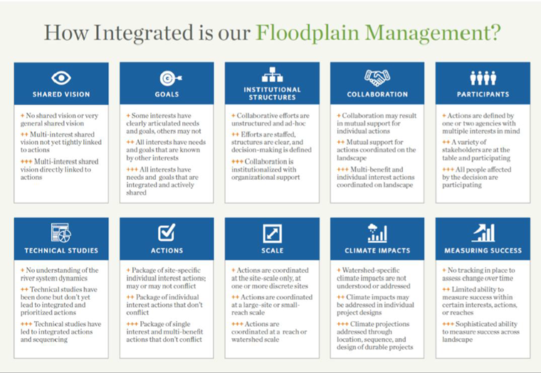
Elements of Integrated Projects or Elements of Integrated Management
Please check the box that best describes your project. Choose only one per section.
    - Shared Vision
☐No shared vision or very general shared visions
☐Multi-interest shared vision not yet tightly linked to actions
☐Multi-interest shared vision directly linked to actions
    - Goals
☐Some interests have clearly anticipated and goals, others may not
☐All interests have needs and goals that are known by other interests
☐All interests have needs and goals that are integrated and actively shared
    - Institutional Structures
☐Collaborative efforts are unstructured and ad-hoc
☐Efforts are staffed, structures are clear, and decision-making is defined
☐Collaboration is institutionalized with organizational support

    - Collaboration
☐Collaboration may results in mutual support for individual actions
☐Mutual support actions coordinated on the landscape
☐Multi-benefit and individual interest actions coordinated on landscape
    - Participants
☐Actions are defined by one or two-agencies with multiple interests in mind
☐A variety of stakeholders are at the table and participating
☐All people affected by the decision are participating
    - Technical Studies
☐No understanding of the river system dynamics
☐Technical studies have been done but don’t yet lead to integrated and prioritized actions
☐Technical studies have led to integrated actions and sequencing
    - Actions
☐Package of site-specific individual interest actions; may or may not conflict
☐Package of individual interest actions that don’t conflict
☐Package of single interest and multi-benefit actions that don’t conflict
    - Scale
☐Actions are coordinated at the site-scale only, at one or more discrete sites
☐Actions are coordinated at a large-scale or small-reach scale
☐Actions are coordinated at a reach or watershed scale
    - Climate Impacts
☐Watershed-specific climate impacts are not understood or addressed.
☐Climate impacts may be addressed in individual project designs
☐Climate projections addressed through location, sequence, and design of durable projects
    - Measuring Success
☐No tracking in place to assess change over time
☐Limited ability to measure success within certain interests, actions or reaches
☐Sophisticated ability to measure success across landscape

- Description of Project and Primary Benefits - Flood Risk Reduction and Floodplain Ecosystem Protection:
Please describe how your project addresses the following issues, following the word count limit for each question. If an integrated response is better than answering each question separately, then word counts described below can be combined for one answer. If this proposed scope of work would fund a portion of a larger project with multiple funding sources, the benefit of the full project can be described. Also please be clear what the specific scope of work is for this funding request i.e. what work will be performed with the current funding request? Answers can be bulleted.
  - Please briefly describe the overall goals for the floodplain area/project site that is the focus of your proposal. (200 word maximum)
  - Evidence of flood hazard reduction – How will your overall strategies and actions and this specific proposal address the flood hazard while avoiding increasing development in flood hazard areas and adverse ecological impacts? If possible quantify the flood hazard reduction e.g. reduction of the base flood elevation or structures removed from the flood hazard area. (300 words maximum)
  - Evidence of benefit to natural floodplain function – Describe, and when possible quantify, the beneficial ecological impact provided by your strategies and actions and this specific proposal. Describe how the proposed strategies and actions will support salmon recovery goals, especially for listed salmon populations and/or salmon populations that benefit tribal treaty rights. (300 words maximum)
  - Explain the benefits, and if possible quantify, that your strategies and actions and this project will provide for agriculture (if relevant). (300 words maximum) Note: Ecology will inquire during pre-application review how you determined your impact to agricultural activities, or decided there were no impacts.
  - Explain, and if possible quantify, other benefits the project will provide (water quality improvements, recreation, or public access, etc.). (300 words maximum)
  - Describe how your project accounts for expected future changes to hydrology, sediment regimes, sea levels, or water supply resulting from other floodplain management efforts, land use changes, shifting climate patterns, extreme weather events, or other causes. (150 words maximum)
  - If applicable, describe how your project leverages existing investments and your potential to secure match. (100 word maximum)
- Collaboration and Plan Consistency (300 words max for each section)
  - Describe your collaboration, participants, and institutional structures to support collaboration that led to this proposal.
  - What scale does the collaboration work at?
  - Which entities have authority over relevant water management and salmon habitat decisions in this area?
  - What governments, organizations, and communities participate or will be included through this work? Please be clear which entities are already engaged and which have yet to be engaged in the process.
  - What processes and structures are being used to clarify common goals and resolve issues or will otherwise be included through this work?
  - Describe how your overall approach relates to existing technical studies, plans, or other planning efforts (Salmon Recovery Plans, Flood Hazard Management Plans, etc.) in the watershed.
  - Describe the frequency of meetings.
  - Describe how your collaboration produced the specific tasks in this application and how it will support implementation.
  - Support letters will be required for the full application. Do you have a process in place to secure letters by the full application?
  - For Puget Sound-linked watersheds: show how the project contributes to the restoration and protection of Puget Sound and how the proposed activities or strategies are consistent with the Puget Sound Partnership Action Agenda.
- Attachment – Maps
Attach these required maps to your application:
- Watershed Scale map – location or scope of project(s) within watershed.
- Site or reach scale map(s) – with project actions identified and flow direction indicated
- Approximate Budget (add rows to table for more tasks as needed).
Please note that the Budget should include only tasks that can be completed in 4 years or less. Projects that will require more than 3-4 years should consider phasing the project over multiple grant cycles. Avoiding having state funds idle is an underlying goal of the FbD grant program.

Table 1. Approximate Budget
Task | Funding Requested from Floodplains by Design | Other Funding for Project** | Total Cost
Task 1 - Administration
**Other sources of funding dedicated to this proposed project. Include the 20% required match unless your community qualifies for a match waiver. Information about the match waiver is available in the Floodplains by Design 2023-25 Funding Guidelines.

Applicant Certification
I certify to the best of my knowledge that the information provided above is true and correct and that I am legally authorized to sign and submit this information on behalf of the organization or agency applying for this grant.
______________________________________________________
Signature Date
______________________________________________________
Printed Name and Title
______________________________________________________
Name of Organization or Agency Applying for Grant

