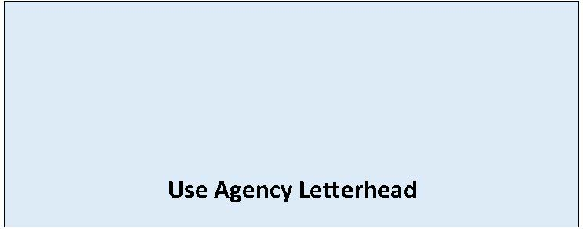

# State Environmental Policy Act

## Modified [Choose One: Determination of NonSignificance or Mitigated Determination of NonSignificance]

**Date of Issuance:** [Enter date]

**Lead Agency:** [Enter name of lead agency]

**Agency Contact:** [Enter name of staff contact, email, phone]

**Lead Agency File Number:** [If applicable, enter agency file number]

**Applicant:** [Enter name of proponent and contact information ]

**Description of Proposal:** [Enter name and description of the proposal. The proposal is the total scope of the project, it is not limited to only a description of the lead agency’s permit decision.]

**Proposal Location:** [Enter location of proposal - address, parcel number and/or latitude-longitude if available]

[Enter lead agency name] has modified its SEPA threshold determination of NonSignificance issued on [Enter date of issuance of prior DNS] in consideration of the following changes: *(also attach updated Environmental Checklist, staff report, addendum or other information)*

[Enter details regarding change of proposal, new information, modification of analysis, and/or mitigation measures]

[Enter name of lead agency] has reaffirmed that this proposal will not have a probable significant adverse impact on the environment. An environmental impact statement (EIS) is not required under [RCW 43.21C.030](https://apps.leg.wa.gov/RCW/default.aspx?cite=43.21C.030)(2)(c). This decision was made after review of a completed environmental checklist and other information on file with the lead agency.

**This information is available at:** [Enter document link]

This modified DNS is issued under [WAC 197-11-340](https://apps.leg.wa.gov/WAC/default.aspx?cite=197-11-340)(2)(f) and does not include additional notice and comment.

This modified DNS is issued after using the optional process in WAC [**197-11-355**](http://app.leg.wa.gov/WAC/default.aspx?cite=197-11-355). There is no further comment period on the DNS.

This modified DNS is issued under WAC [**197-11-340**](http://app.leg.wa.gov/WAC/default.aspx?cite=197-11-340)(2); the lead agency will not act on this proposal for 14 days from the date of issuance.

**Comments must be submitted by:** [Enter **date** and **time** comments due]

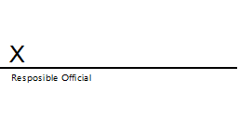

**Signature Date:** [Enter date]

**(Optional)**

You may appeal this determination to [name of agency] at [address of agency] no later than [enter date of appeal deadline] by [method of filing appeal]. You should be prepared to make specific factual objections. Contact [enter contact info] to read or ask about the procedures for SEPA appeals.

There is no agency appeal.