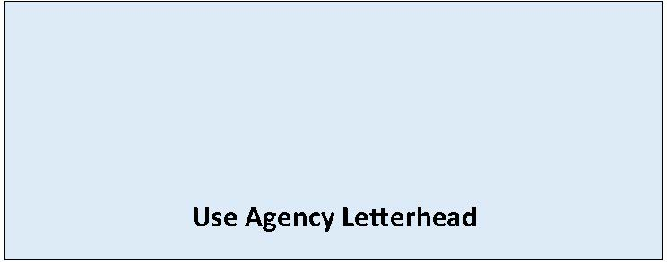

Notice of Application

[Choose One: Optional DNS or MDNS Process]
Date of Issuance: [Enter date]
[Enter city or county name] has received a permit application for the following project.
Date of Permit Application: [Enter date of permit application submittal]
Date of Determination of Completeness: [Enter date of application determined complete]
Date of Notice of Application: [Enter date of Notice of Application]
Comment Due Date: [Enter date and time comments due]
Agency Contact: [Enter name of staff contact, email, and phone number]
Agency File Number: [If applicable, enter agency file number]
Description of Proposal: [Enter name and description of the proposal. The proposal is the total scope of the project, it is not limited to only a description of the lead agency’s permit decision.]
Location of Proposal: [Enter address, parcel number and/or latitude-longitude if available]
Project Applicant: [Enter name, phone, and email of Applicant/Proponent]
SEPA Environmental Review: [Enter city or county name] has reviewed the proposed project for probable adverse environmental impacts and expects to issue a [Choose one: Determination of Nonsignificance (DNS) OR Mitigated Determination of Nonsignificance (MDNS)]. The optional [Enter DNS OR MDNS] process in WAC 197-11-355 is being used. This may be your only opportunity to comment on the environmental impacts of the proposed project.
(If issuing a NOA with likely MDNS complete mitigation section below, for DNS delete)
The following conditions are proposed to mitigate the adverse environmental impacts of the proposal:
[List impacts and associated mitigation measures proposed under SEPA. These conditions are in addition to mitigation required by the development regulations listed below.]
Agencies, tribes, and the public are encouraged to review and comment on the proposed project and its probable environmental impacts. Comments must be submitted by the date and time noted above to: [Enter email/URL where to submit comments].
Required Permits: The following local, state and federal permits/approvals are needed for the proposed project: [Enter the local, state and/or federal permits/approvals needed for this proposed project].
Required Studies: [List any studies that have been completed or will be completed for this proposal]
Existing Environmental Documents: [List any existing environmental documents used as part of the review process for this proposal]
Preliminary determination of the development regulations that will be used for project mitigation and consistency: [Enter applicable development regulations]
Public Hearing: [Include date, time, place, and type of hearing, if applicable]
[Enter any other information required by RCW 36.70B.110 or deemed appropriate]

