Directions: Use this clean energy PEIS MDNS/Adoption Template when adopting an Ecology clean energy PEIS.

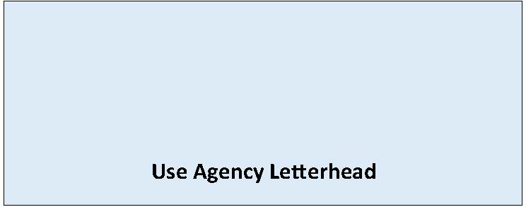

State Environmental Policy Act

Mitigated Determination of NonSignificance
Adoption of Existing Document
Date of Issuance: [Enter date]
Lead Agency: [Enter name of lead agency]
Agency Contact: [Enter name of staff contact, email, phone]
Lead Agency File Number: [Enter lead agency file number, if applicable]
Description of Proposal: [Enter name and description of the proposal. The proposal is the total scope of the project, it is not limited to only a description of the lead agency’s permit decision.]
Applicant: [Enter name of and contact information of the proponent]
Location of Proposal: [Enter address, parcel number, or other identifying information]

Title of Document Being Adopted: (Check applicable PEIS title from list below)

☐Final Programmatic Environmental Impact Statement (PEIS) for Green Hydrogen Energy Facilities in Washington State

☐Final Programmatic Environmental Impact Statement (PEIS) for Utility-Scale Onshore Wind Energy Facilities in Washington State

☐Final Programmatic Environmental Impact Statement (PEIS) for Utility-Scale Solar Energy Facilities in Washington State

Date Adopted Document Prepared: June 2025

Description of Document Being Adopted:

The Washington State Department of Ecology (Ecology) issued a PEIS that assessed probable significant adverse environmental impacts from [include as applicable: green hydrogen energy facilities/ utility-scale onshore wind energy facilities/ utility-scale solar energy facilities] under Revised Code of Washington (RCW) 43.21C.535. The PEIS provides thorough, factual, and impartial information about potential environmental impacts associated with constructing, operating, and decommissioning the facilities analyzed. The findings identify resources where significant impacts are not likely as well as resources that could be significantly impacted.

State and local agencies must consider the information in the PEIS, as well as other publicly available information and site-specific details, to inform their environmental reviews and permitting decisions.

The PEIS evaluates the following resources areas at a broad level and also considers cumulative impacts:

- Aesthetics and visual quality
- Air quality and greenhouse gases
- Biological resources
- Earth resources
- Energy and natural resources
- Environmental health and safety
- Environmental justice
- Historic and cultural resources
- Land use
- Noise and vibration
- Public services and utilities
- Recreation
- Transportation
- Tribal rights, interests, and resources
- Water resources

The PEIS identifies measures to avoid, reduce, and mitigate potential environmental impacts.

After independent review, the lead agency has adopted the PEIS as being appropriate for the proposed project. The PEIS is available at: (choose as applicable)

☐Final PEIS for Green Hydrogen Energy Facilities in Washington State
https://apps.ecology.wa.gov/separ/Main/SEPA/Record.aspx?SEPANumber=202502653

☐Final PEIS for Utility-Scale Onshore Wind Energy Facilities in Washington State
https://apps.ecology.wa.gov/separ/Main/SEPA/Record.aspx?SEPANumber=202502663

☐Final PEIS for Utility-Scale Solar Energy Facilities in Washington State
https://apps.ecology.wa.gov/separ/Main/SEPA/Record.aspx?SEPANumber=202502662

The lead agency conducted a site-specific environmental review of the proposed project, including evaluating additional information as necessary to determine whether there were unique aspects of the project that were not evaluated in the PEIS.

The lead agency has determined that this proposal will not have a probable significant adverse impact on the environment. Pursuant to WAC 197-11-350(3), the proposal has been clarified, changed, and conditioned to include the following mitigation measures to avoid, minimize or compensate for probable significant impacts. An environmental impact statement (EIS) is not required under RCW 43.21C.030. The necessary mitigation measures are listed below. The Environmental Checklist and [Enter additional supporting document(s) such the PEIS Project Siting and Design Worksheet and PEIS Project Consistency Worksheet, if applicable] are available at [Enter webpage or document links].

The following conditions are identified to mitigate the adverse environmental impacts of the proposal:

[List mitigation measures/conditions that will be required under SEPA. Identify any mitigation measures described in Appendix A of the PEIS used to meet requirements of RCW 43.21C.538 for probable significant adverse environmental impacts. List mitigation measures for impacts not addressed in the PEIS. Note these conditions are in addition to mitigation required by the development regulations.]

This MDNS is issued under WAC 197-11-350; the lead agency will not act on this proposal for 14 days from the date of issuance. Comments must be submitted by: [Enter date and time comments due]. Submit comments to: [Enter email/URL where to submit comments]

Responsible Official: [Enter name of SEPA responsible official]
Position/Title: [Enter position or title of SEPA responsible official]
Address: [Enter agency address]
Phone: [Enter phone number of responsible official]
Email: [Enter email]
Signature Date: [Enter date]

(Optional)
☐ You may appeal this determination to [name of agency] at [address of agency] no later than [date of appeal deadline] by [method of filing appeal]. You should be prepared to make specific factual objections.
☐ There is no agency appeal.

