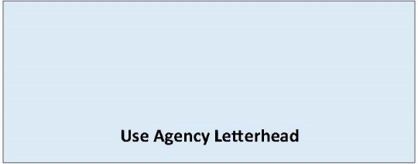

State Environmental Policy Act

Determination of Significance and Request for Comments on Scope of EIS
Date of Issuance: [Enter date]
Lead Agency: [Enter name of lead agency]
Agency Contact: [Enter name of staff contact, email, phone]
Lead Agency File Number: [Enter file number, if applicable]
Description of Proposal: [Enter name and description of the proposal. The proposal is the total scope of the project, it is not limited to only a description of the lead agency’s permit decision.]
Applicant: [Enter name of proponent and contact information]
Location of Proposal: [Enter address, parcel number, or other identifying information]
EIS Required. The lead agency has determined this proposal is likely to have a significant adverse impact on the environment. An environmental impact statement (EIS) is required under RCW 43.21C.030 (2)(c) and will be prepared. An environmental checklist or other materials indicating likely environmental impacts can be reviewed at [Add project webpage].
The lead agency has identified the following areas for discussion in the EIS: [Identify elements of the environment and specific areas of analysis that will be covered in the EIS]
Scoping. Agencies, affected tribes, and members of the public are invited to comment on the scope of the EIS. You may comment on alternatives, mitigation measures, probable significant adverse impacts, and licenses or other approvals that may be required. The method and deadline for giving us your comments is:
[Enter the email, website, and/or other form of comment submittal]
[Enter date and time comments due.]

Responsible Official: [Enter name of SEPA responsible official]
Position/Title: [Enter position or title of SEPA responsible official]
Address: [Enter agency address]
Phone: [Enter phone number of responsible official]
Email: [Enter email]
Signature Date: [Enter date]
(Optional)
Appeal process: [Enter appeal process for this DS if available]

